## Front End Engineering-II

Project Report

Semester-IV (Batch-2022)

Title of the Project: THE SPACIOUS



**Supervised By: Submitted By:**

Raveesh Samkaria Name:Taney Sharma

Roll no: 2210990887

Group: G-13

**Department of Computer Science and Engineering**

## Chitkara University Institute of Engineering & Technology,

## Chitkara University, Punjab

**CONTENTS**

|  |  |  |
| --- | --- | --- |
| **S.NO** | **CONTENT** | **PAGE.NO** |
| **1** | **Abstract** | **1-2** |
| **2** | **Introduction** | **2** |
| **3** | **Problem Definition and Requirements** | **3** |
| **4** | **Proposed design** | **4-6** |
| **5** | **HTML code** | **7-11** |
| **6** | **CSS code** | **11-19** |
| **7** | **Result** | **20-29** |

**Abstract:**

HTML (Hypertext Markup Language) and CSS (Cascading Style Sheets) form the backbone of web development.

**HTML (Hypertext Markup Language)** is the standard markup language for creating web pages and web applications. Let’s break down what HTML means:

**Hyper Text**: Hyper-text refers to “text within text.” When a piece of text contains a link, it becomes a hypertext. Clicking on a link takes you to a new webpage, and that action is considered hypertext. Essentially, hypertext allows you to link different web pages (which are HTML documents) together.

**Markup Language**: A markup language is a computer language used to apply layout and formatting conventions to a text document. It makes text more interactive and dynamic. With HTML, you can turn plain text into images, tables, links, and more.

**Web Page**: A web page is a document commonly written in HTML and interpreted by a web browser. You can identify a web page by entering its URL. Web pages can be static or dynamic. HTML allows us to create static web pages that display nicely in web browsers.

**Let’s break down the components:**

**<!DOCTYPE>:** Defines the document type or instructs the browser about the HTML version.

**<html>:** Informs the browser that it’s an HTML document. The content between the <html> tags describes the web document.

**<head>:** Contains metadata (information about the document) and should be the first element inside <html>.

**<title>**: Adds the title of the HTML page (appears at the top of the browser window).

**<body>:** Contains the main content visible to the end user.

**CSS (Cascading Style Sheets)** is a fundamental technology used in web development. Let’s dive into what CSS entails:

**Definition**:

**CSS** is a **style sheet language** that specifies how HTML elements should be **presented and styled** on various media, including screens, paper, and other devices.

It works alongside HTML and JavaScript to create visually appealing and well-organized web pages.

**Key Points**:

**Presentation and Styling**: CSS defines the visual appearance of web content. It controls aspects such as fonts, colors, spacing, layout, and positioning.

**Cascading**: The term “cascading” refers to the order in which styles are applied. Multiple styles can be combined, and the most specific rule takes precedence.

**Stylesheets**: CSS rules are typically stored in external .css files. These files contain style definitions that can be reused across multiple web pages.

**Efficiency**: By using CSS, you can maintain a consistent look and feel across an entire website without duplicating code.

**Introduction:**

**Background:**Provide context for the project, explaining why it is relevant and necessary.

**Objectives:**Clearly state the goals and objectives of the project.

**Significance:**Discuss the importance and potential impact of the project.

**Problem Definition and Requirements**

**Problem Statement:** Describe the specific problem or challenge addressed by the project.

**Software Requirements:** List the software tools, libraries, and technologies used.

**Text Editors / Integrated Development Environments (IDEs):**

**Visual Studio Code (VS Code)**: A popular free code editor with excellent HTML and CSS support.

**Browser Extensions**:

**Live Server**: Instantly reloads your HTML and CSS changes.

**CSS Viewer**: Inspect CSS properties on any webpage.

**Hardware Requirements:**Specify any hardware components required for the project.

**Web Browser**:

Install popular web browsers for testing your HTML and CSS:

**Google Chrome**

**Text Editor or IDE**:

Choose a text editor or integrated development environment (IDE) for writing code:

**Visual Studio Code (VS Code)**

**Proposed Design / Methodology:**

**Design:**



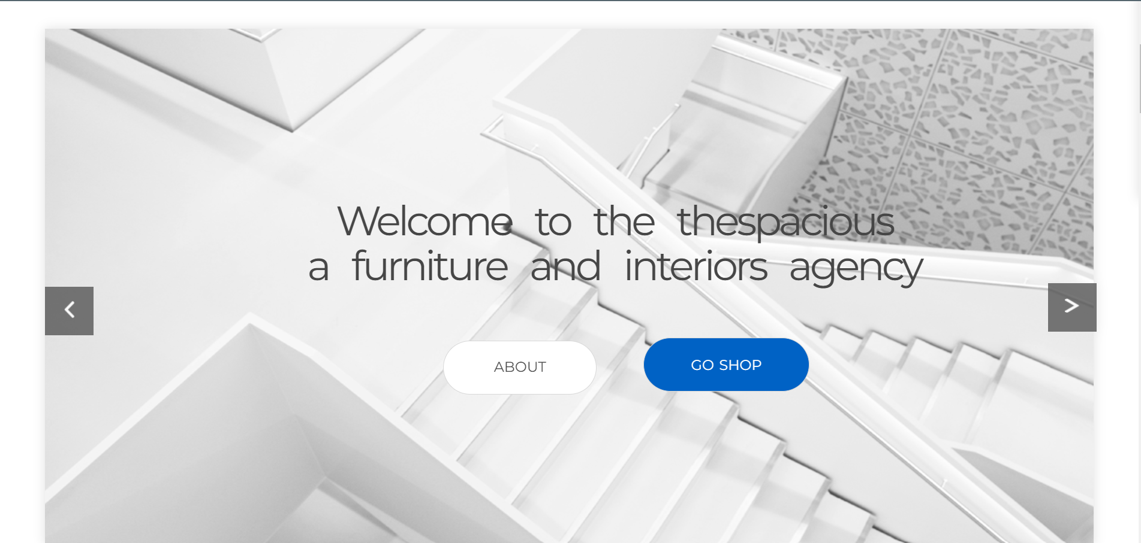

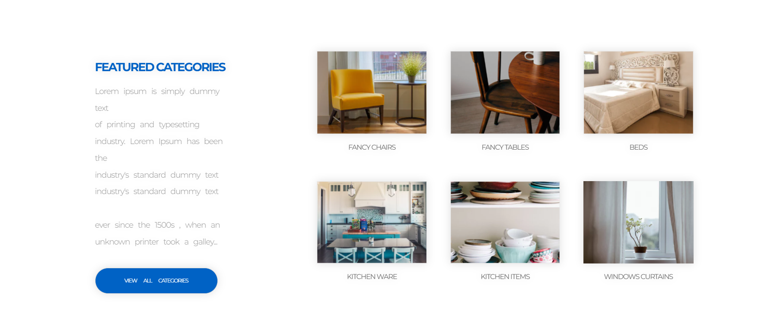

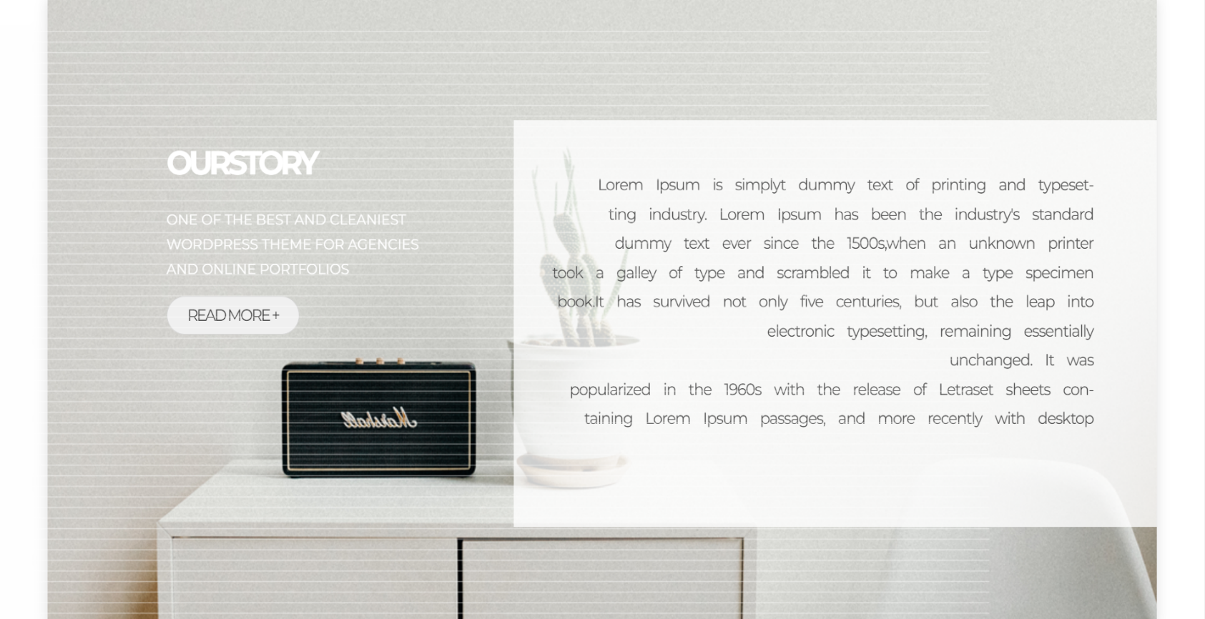

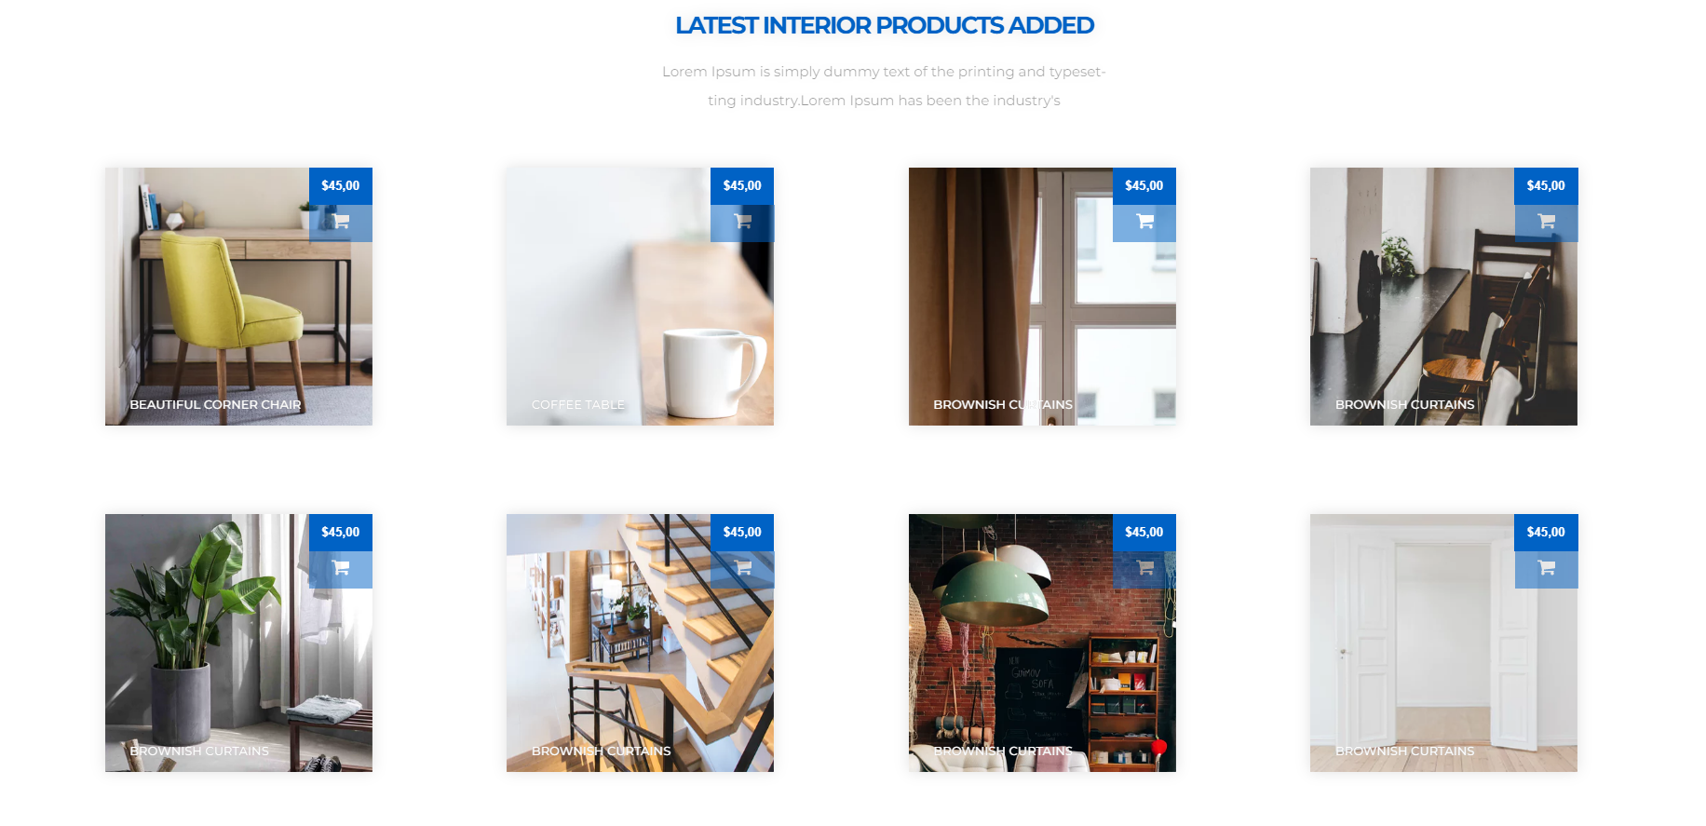

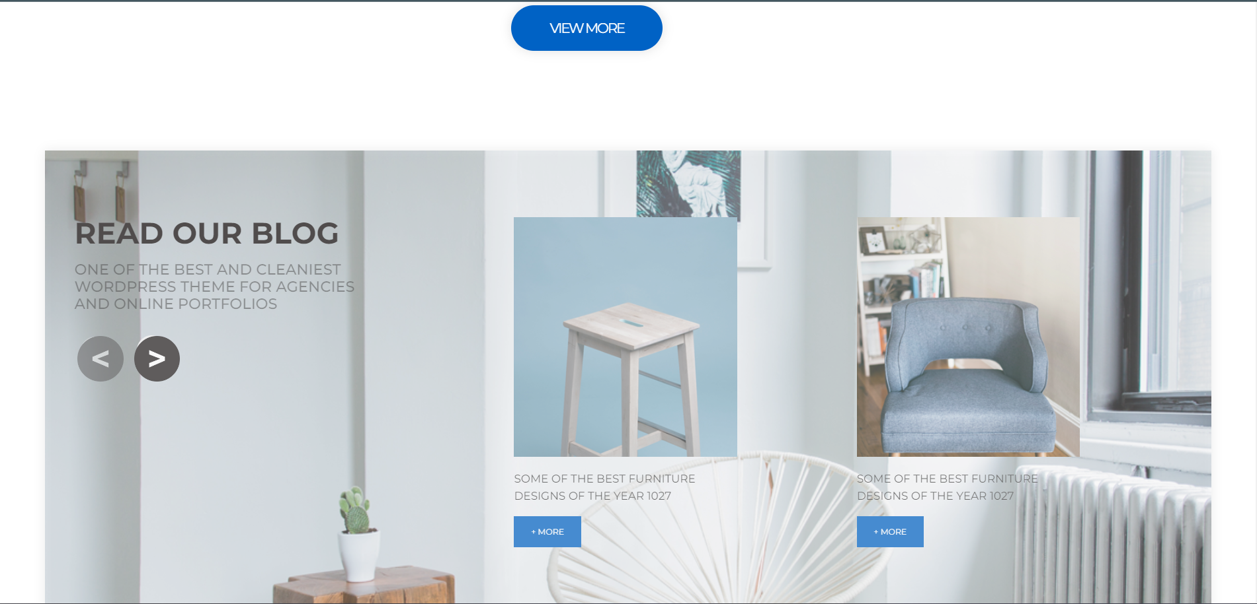

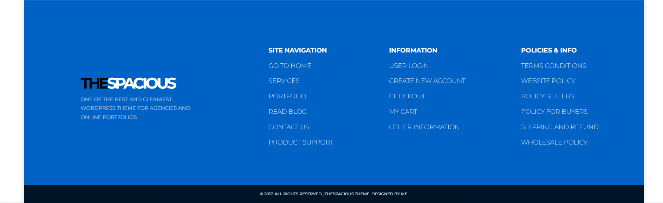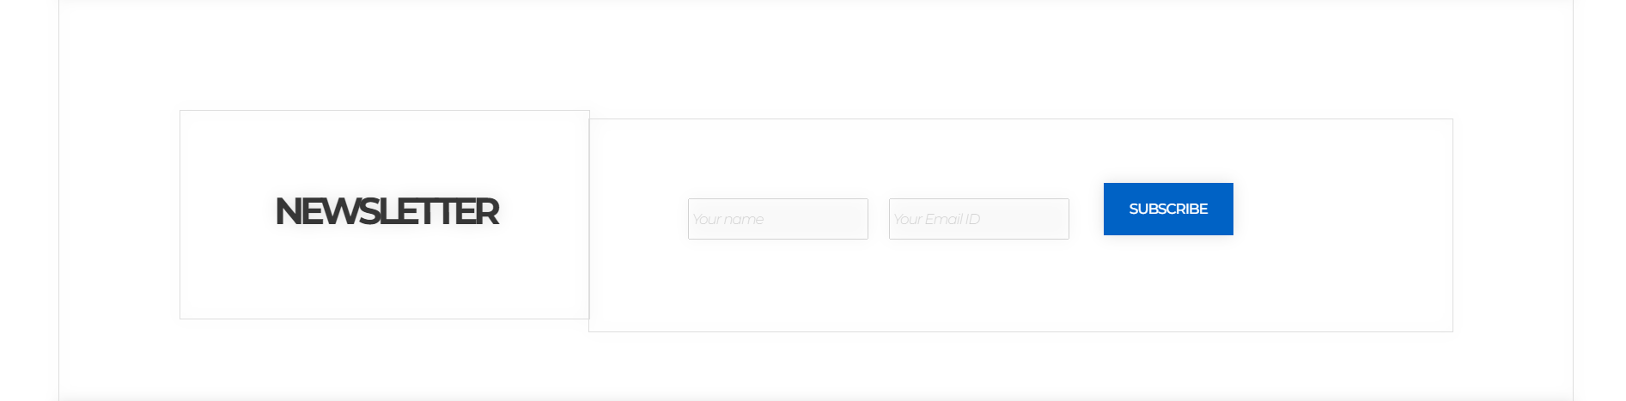

**Source code:**

**HTML CODE:**

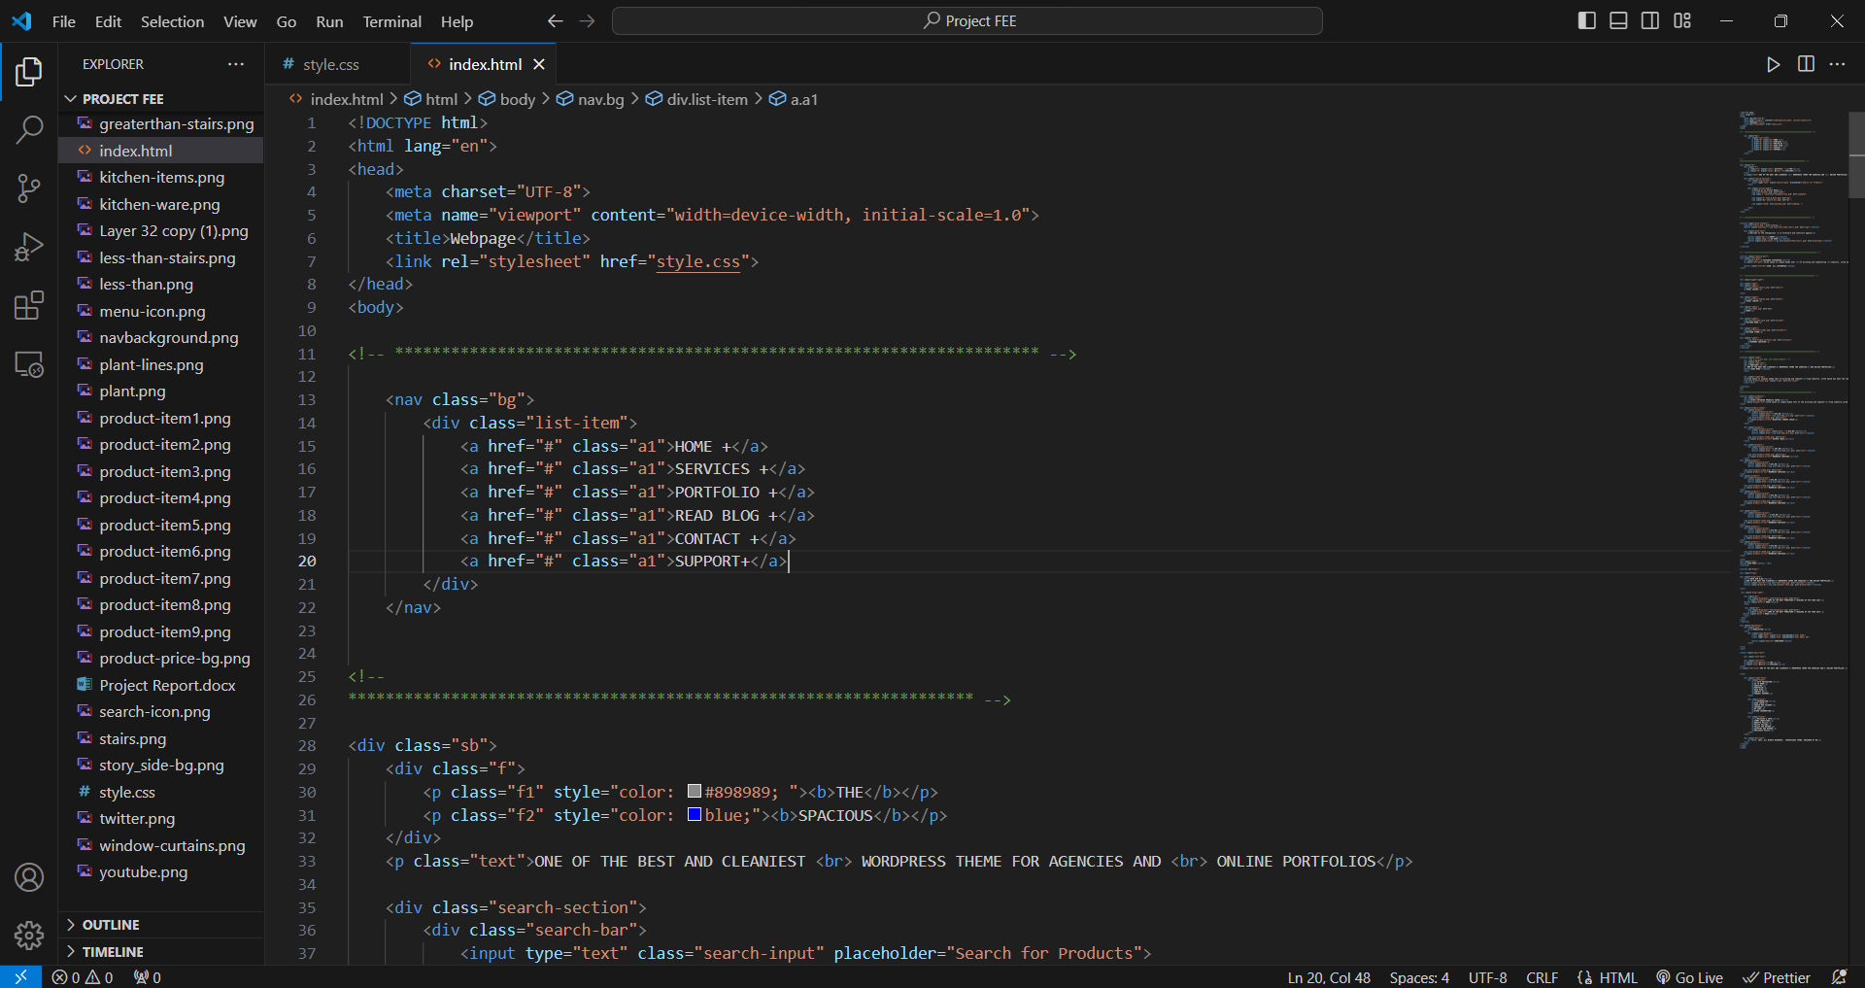

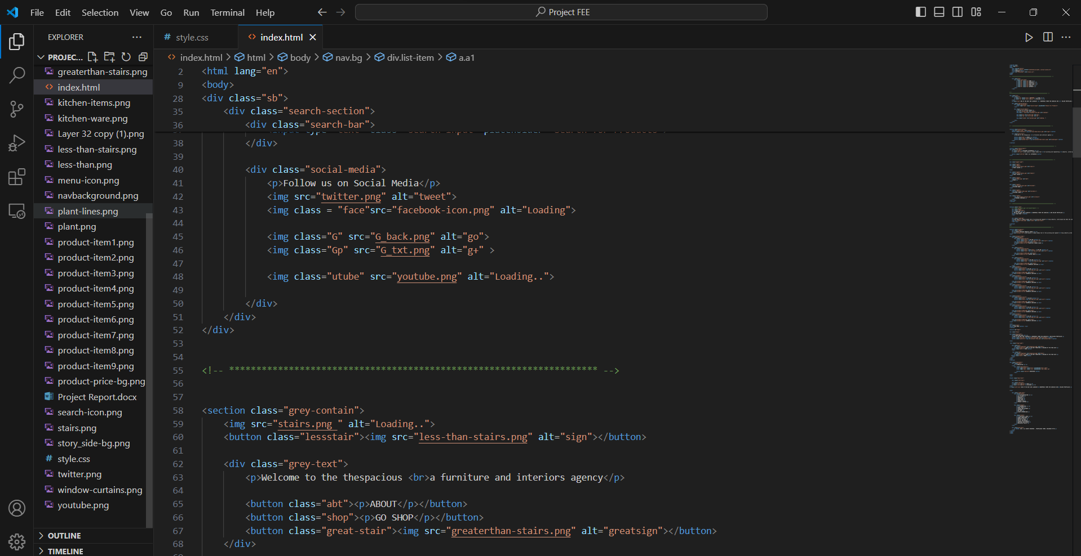

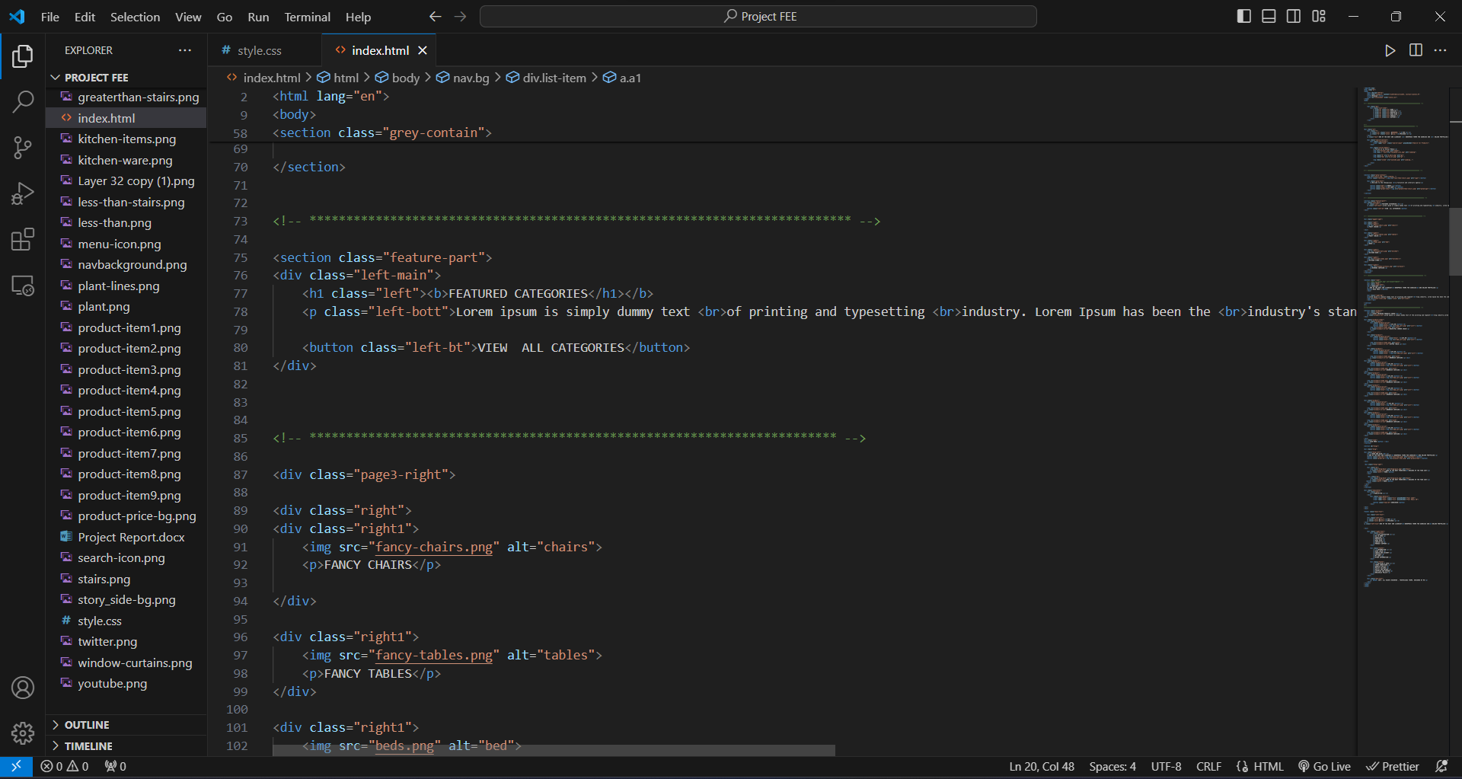

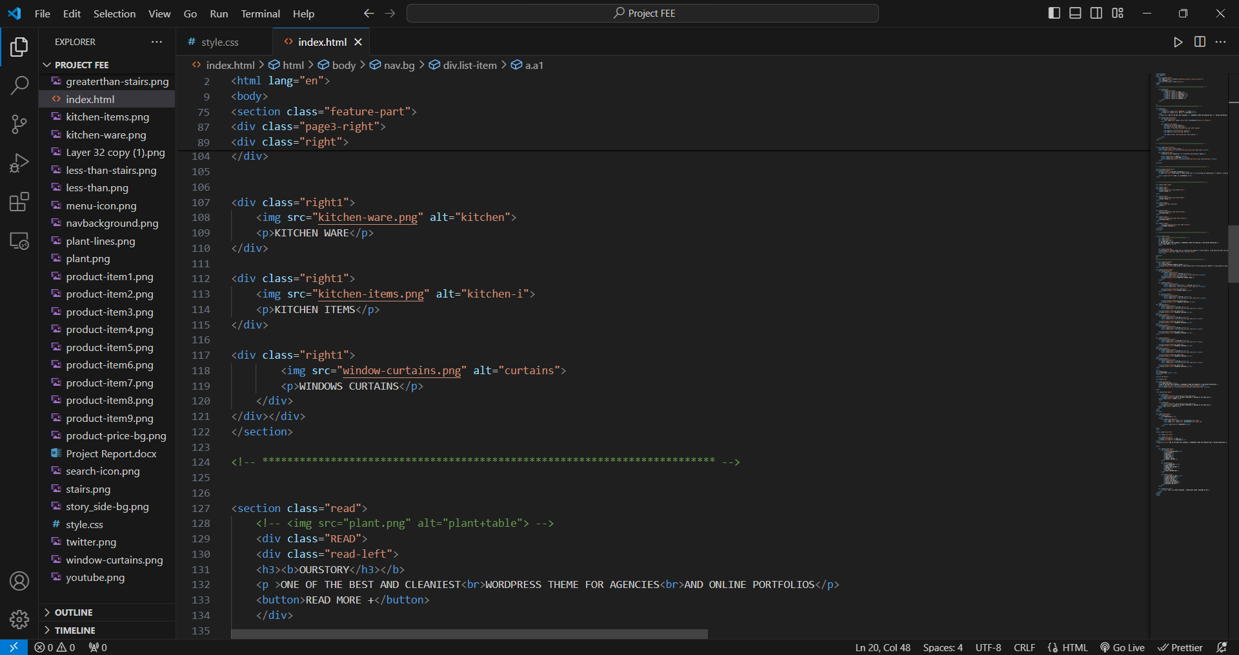

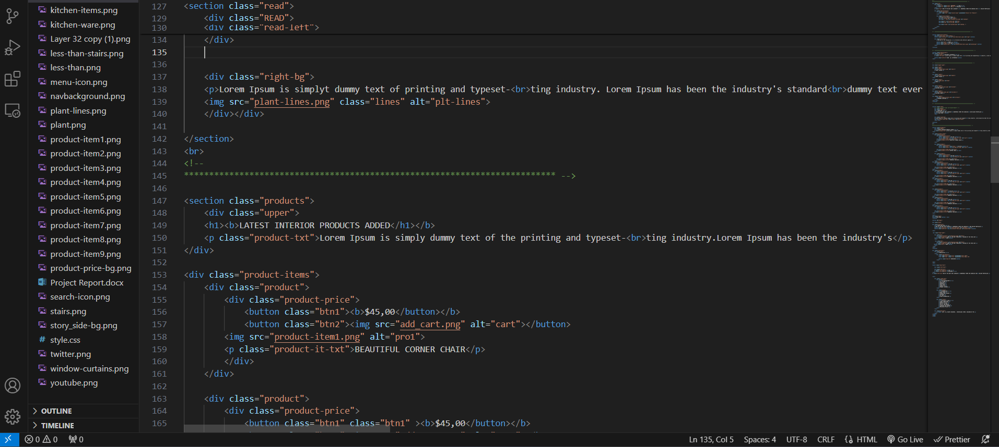

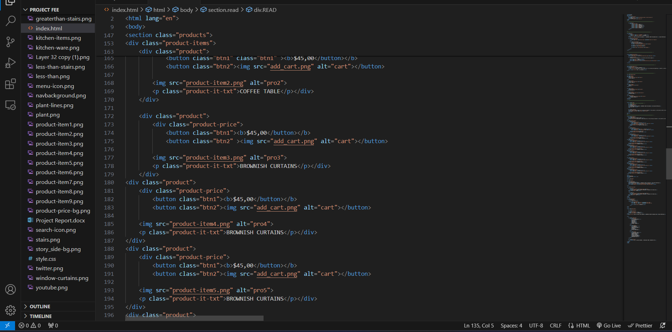

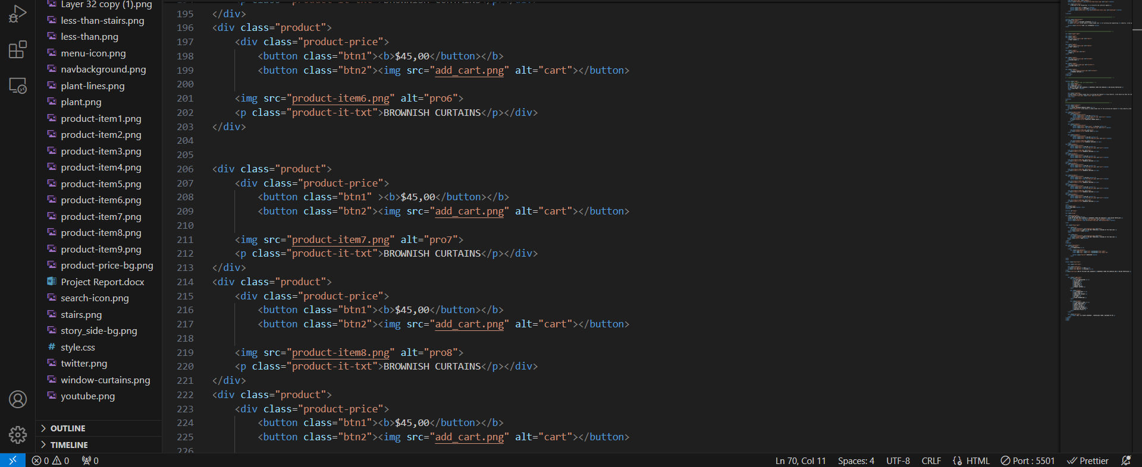

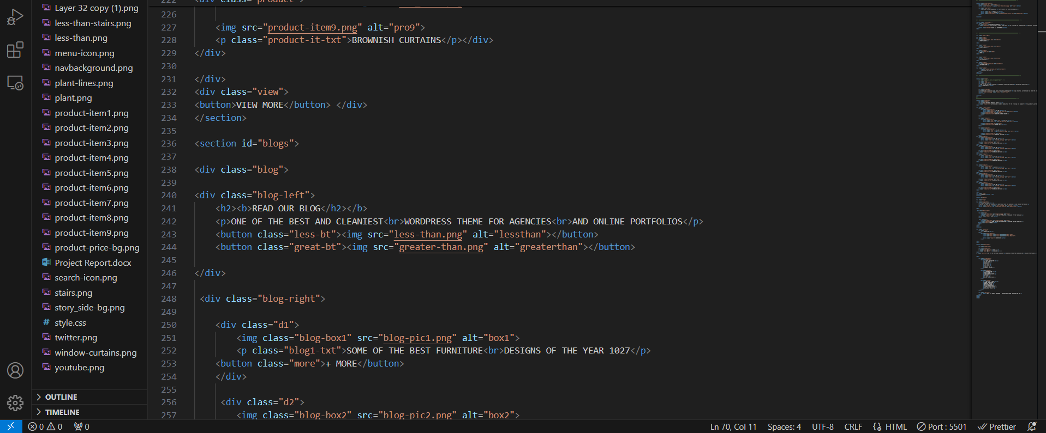

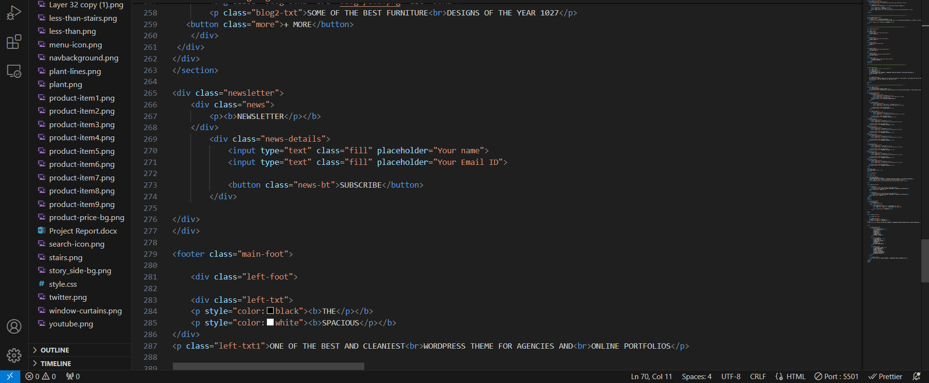

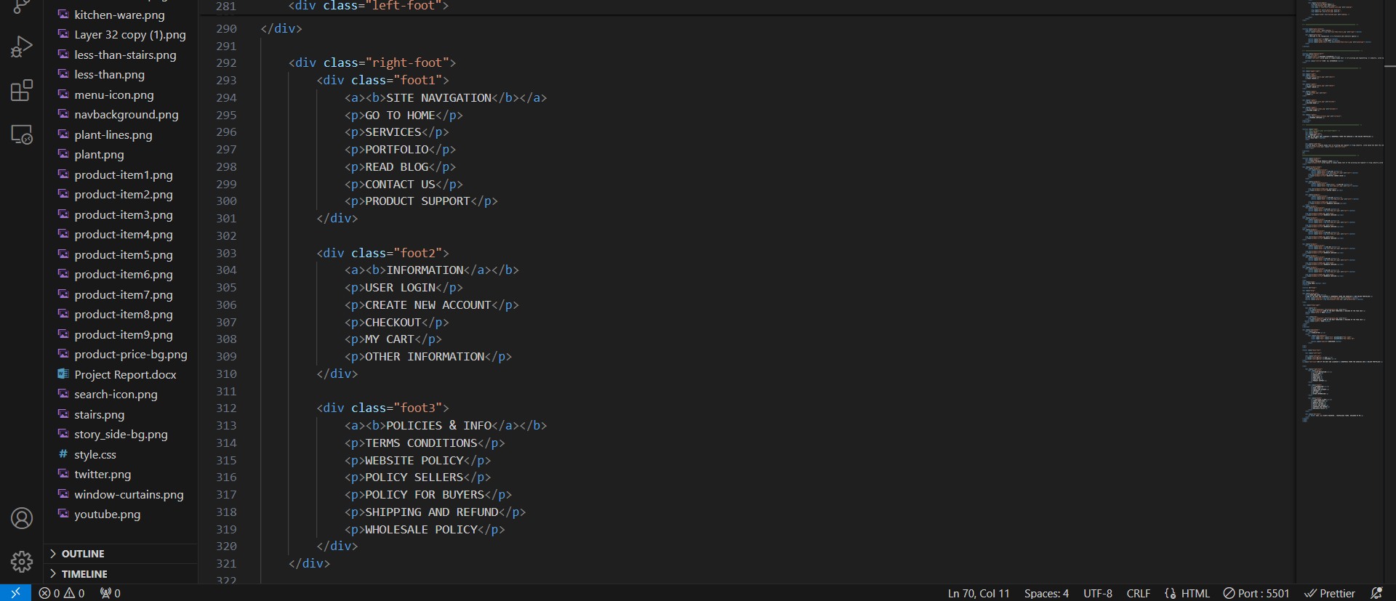

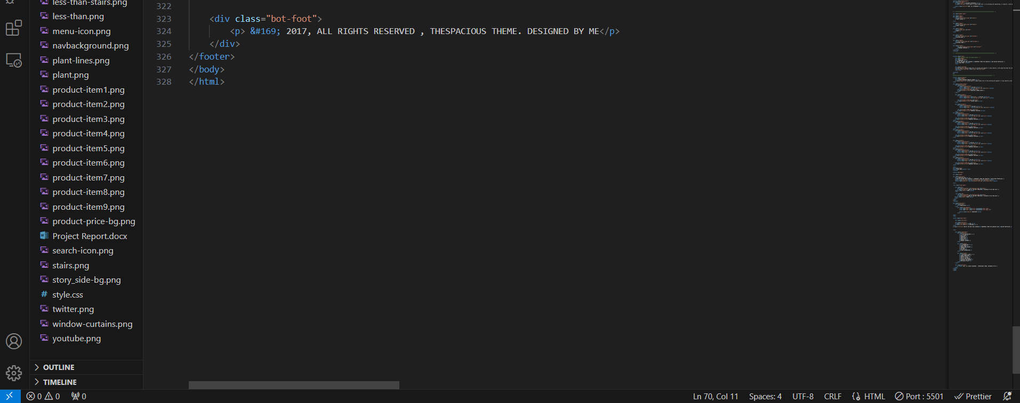

**CSS CODE: DESKTOP**

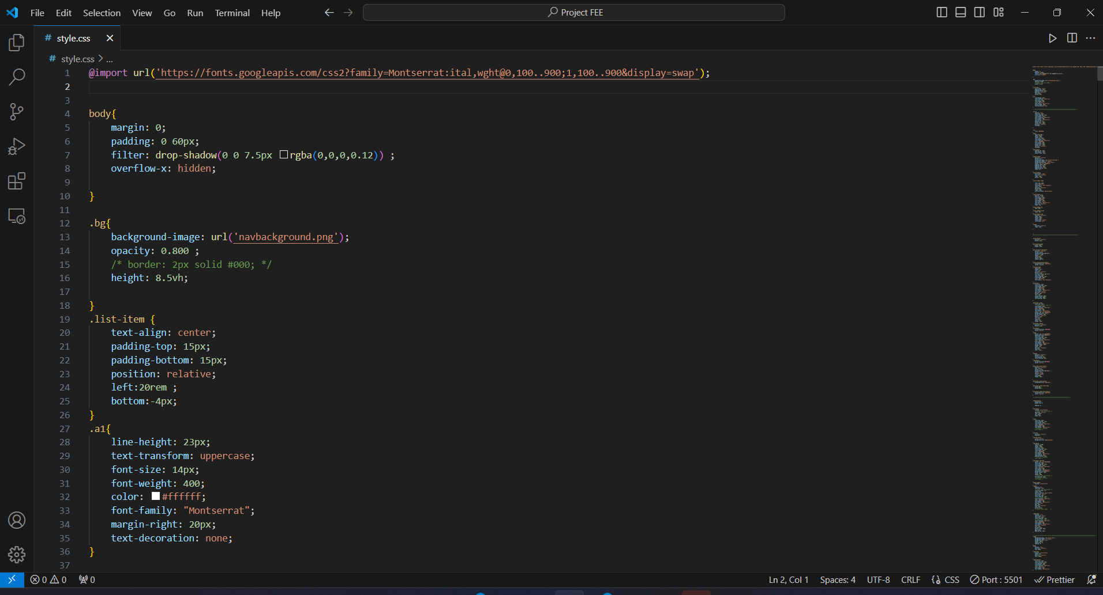

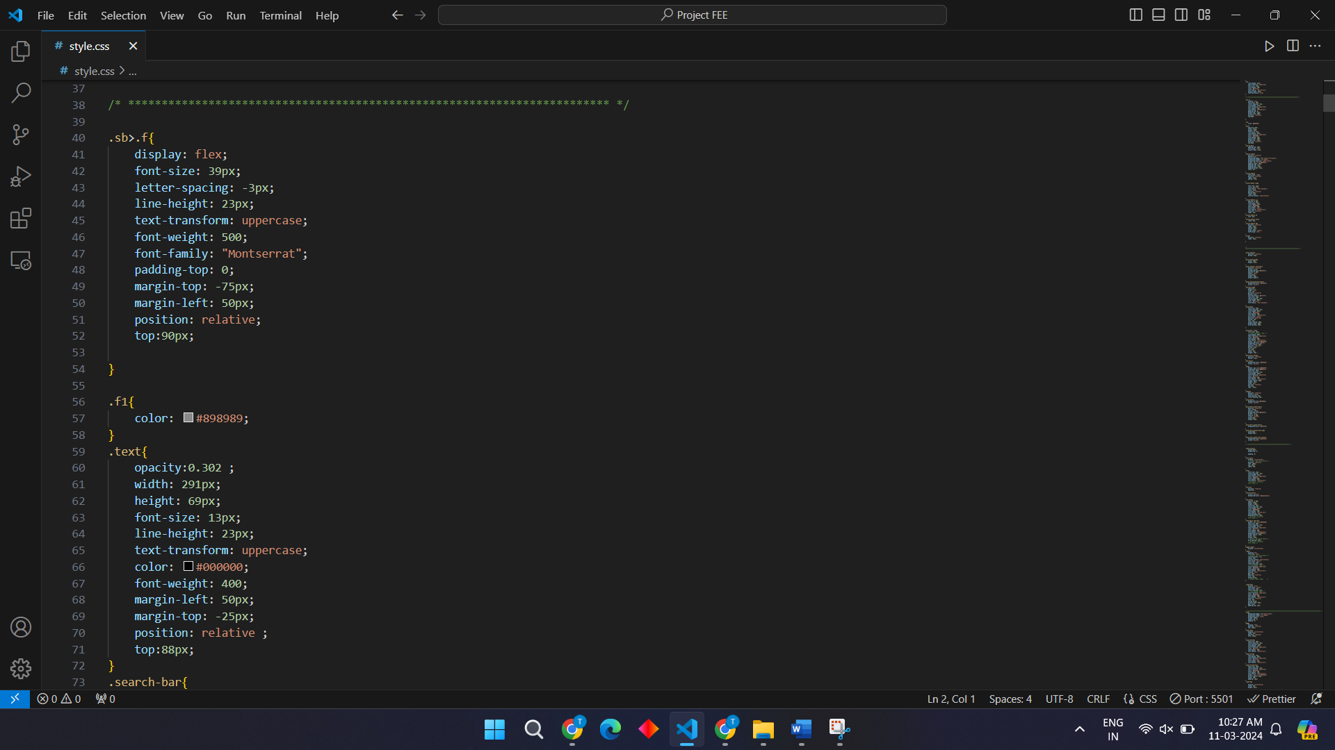

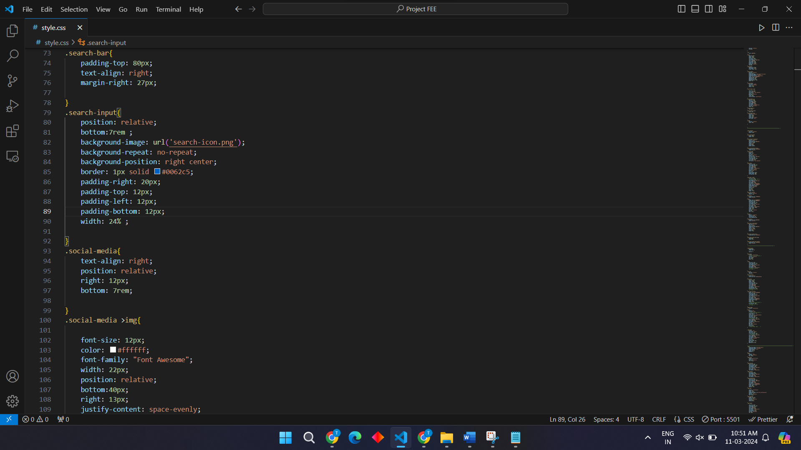

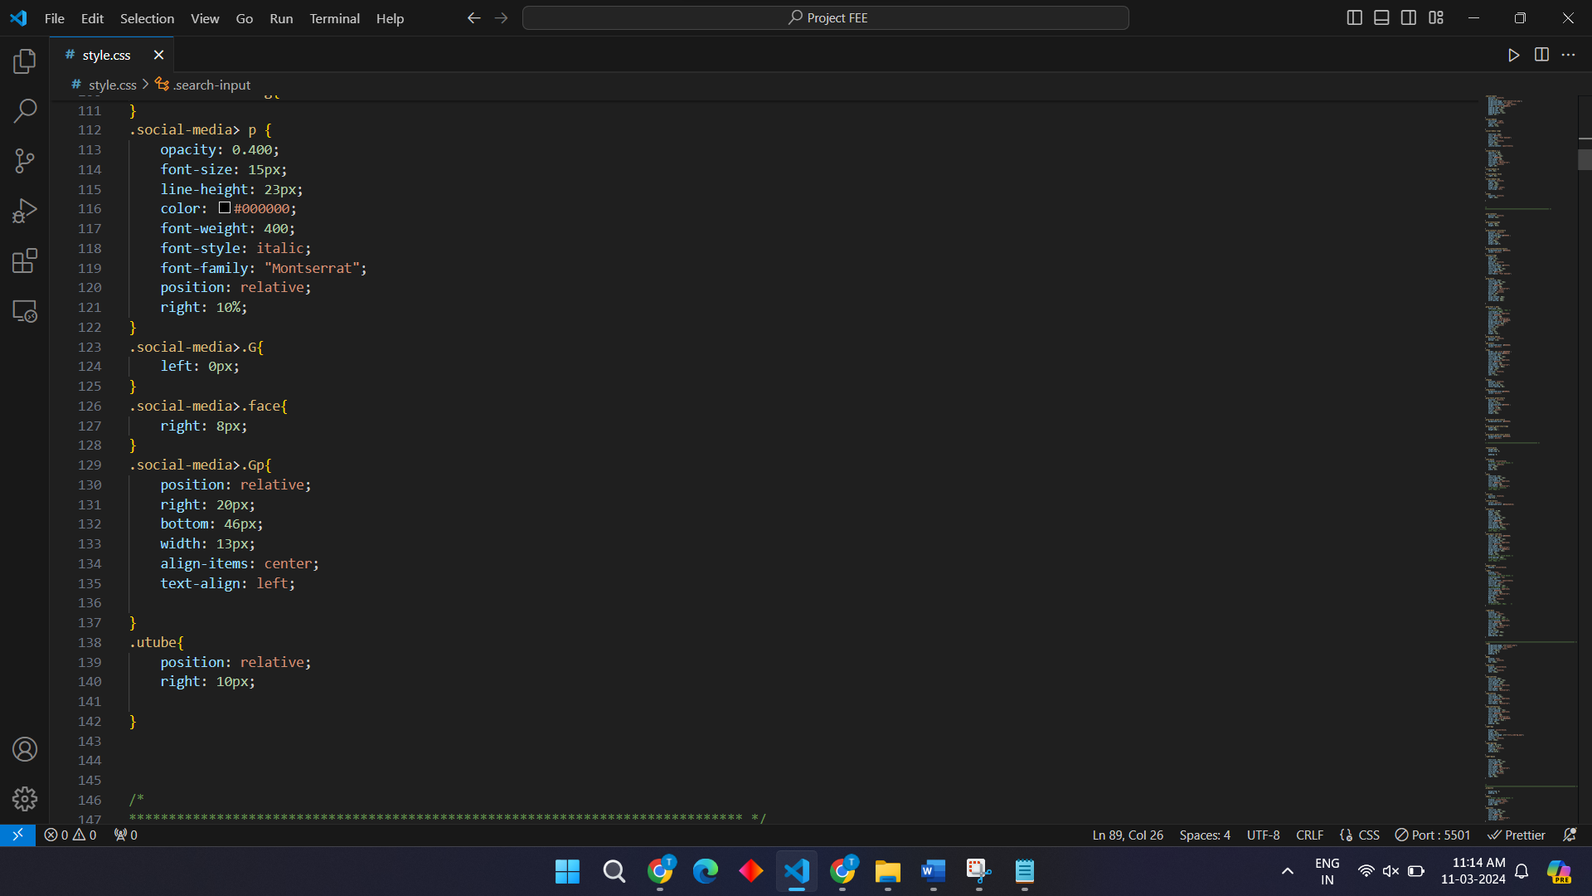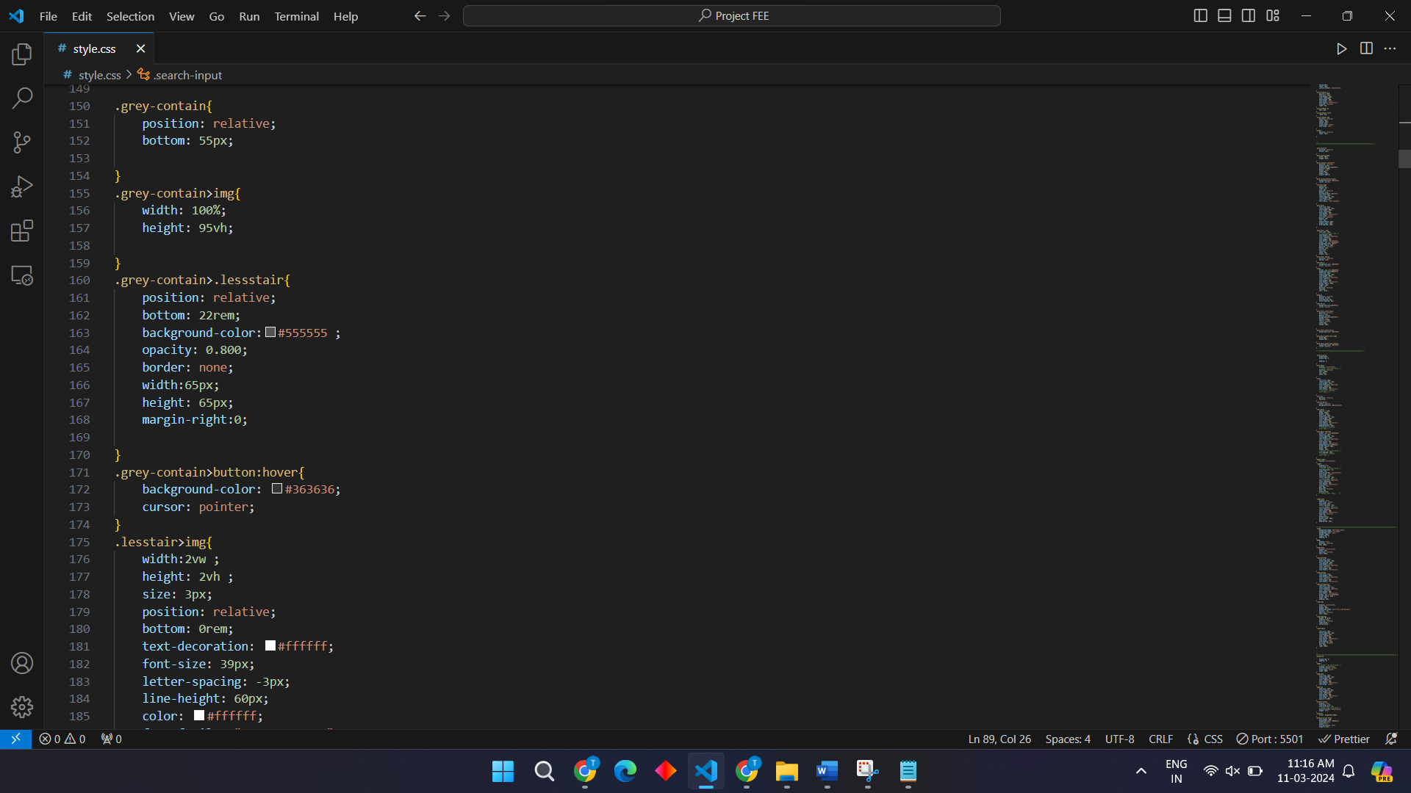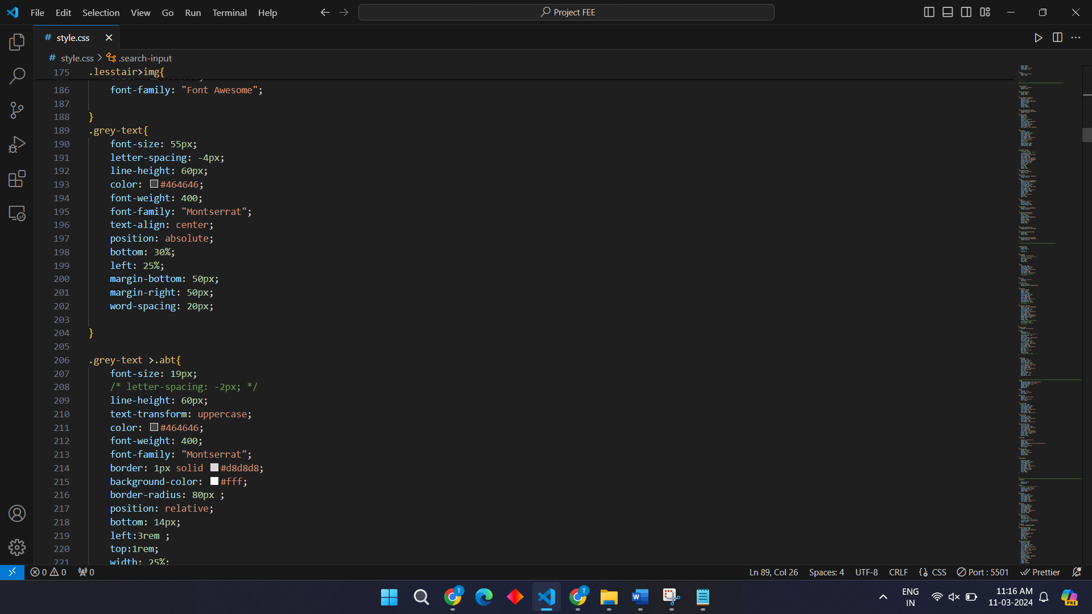

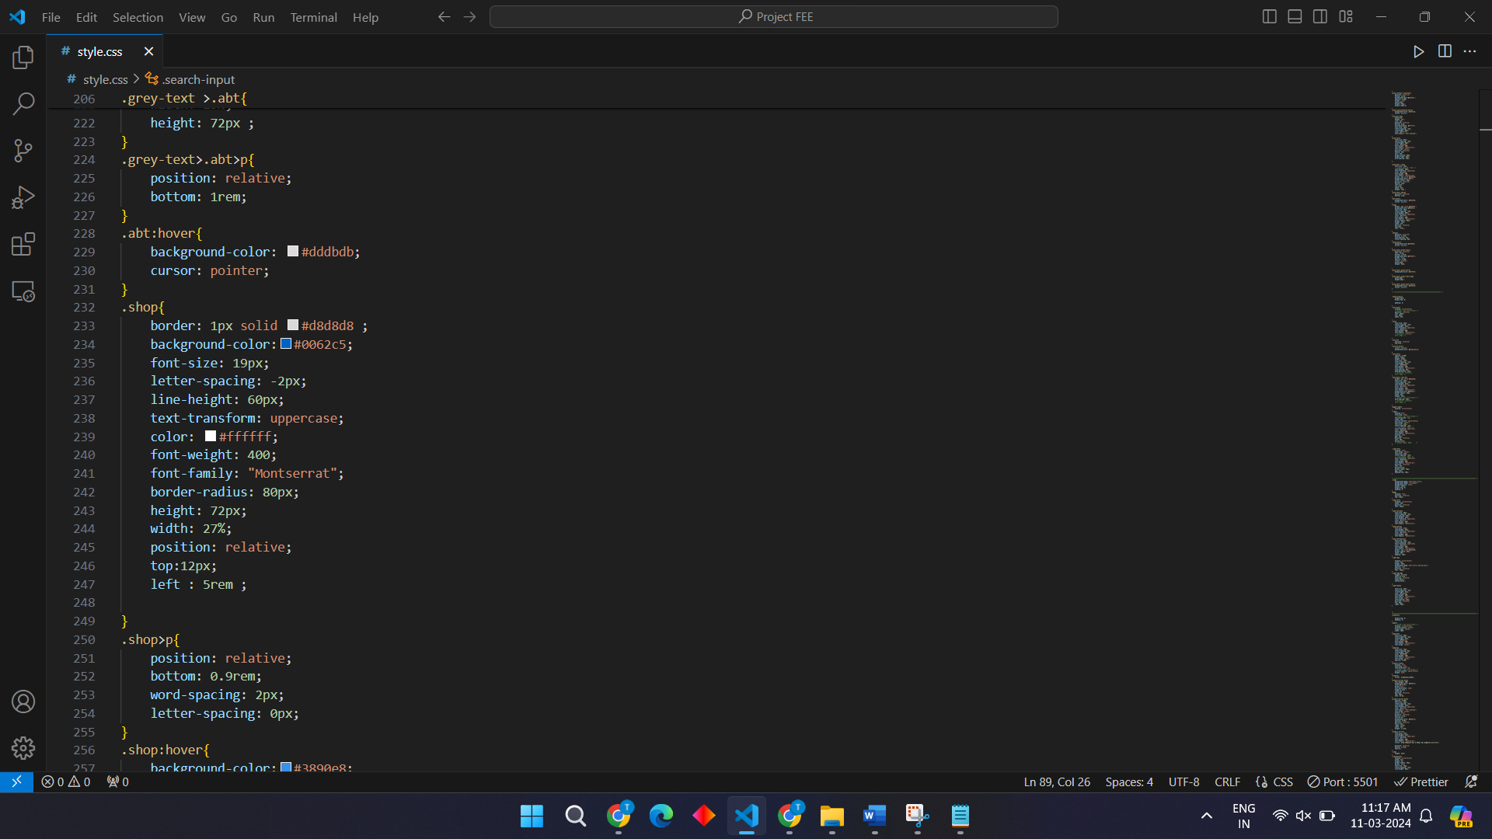

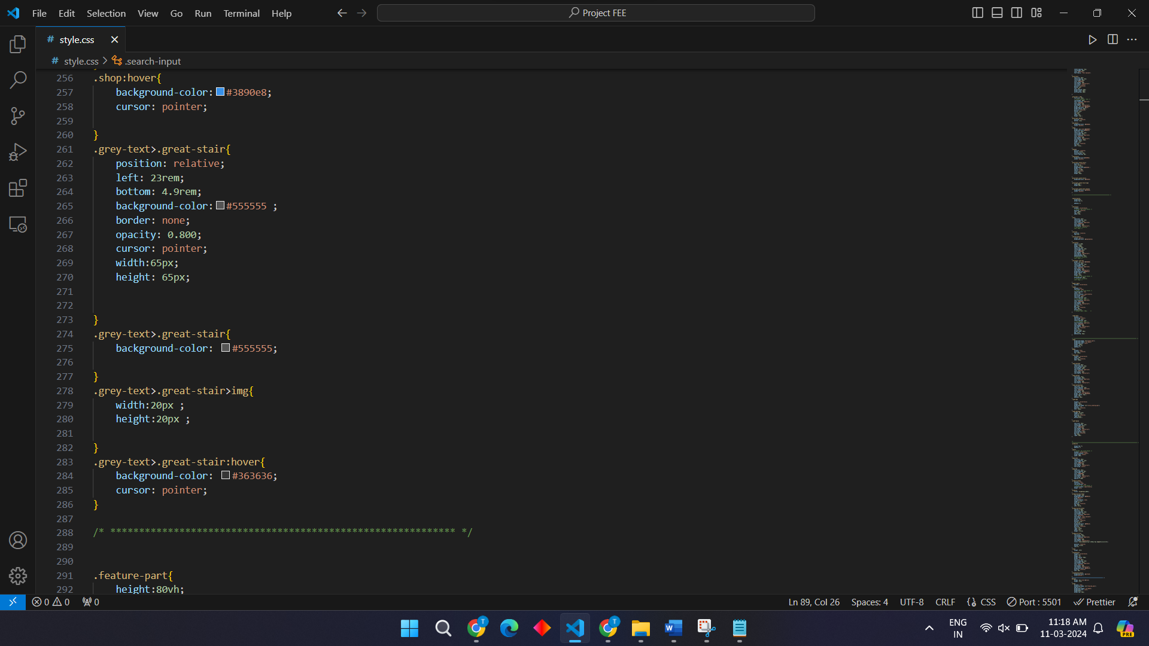

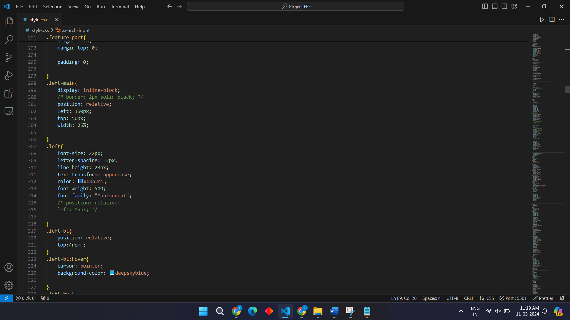

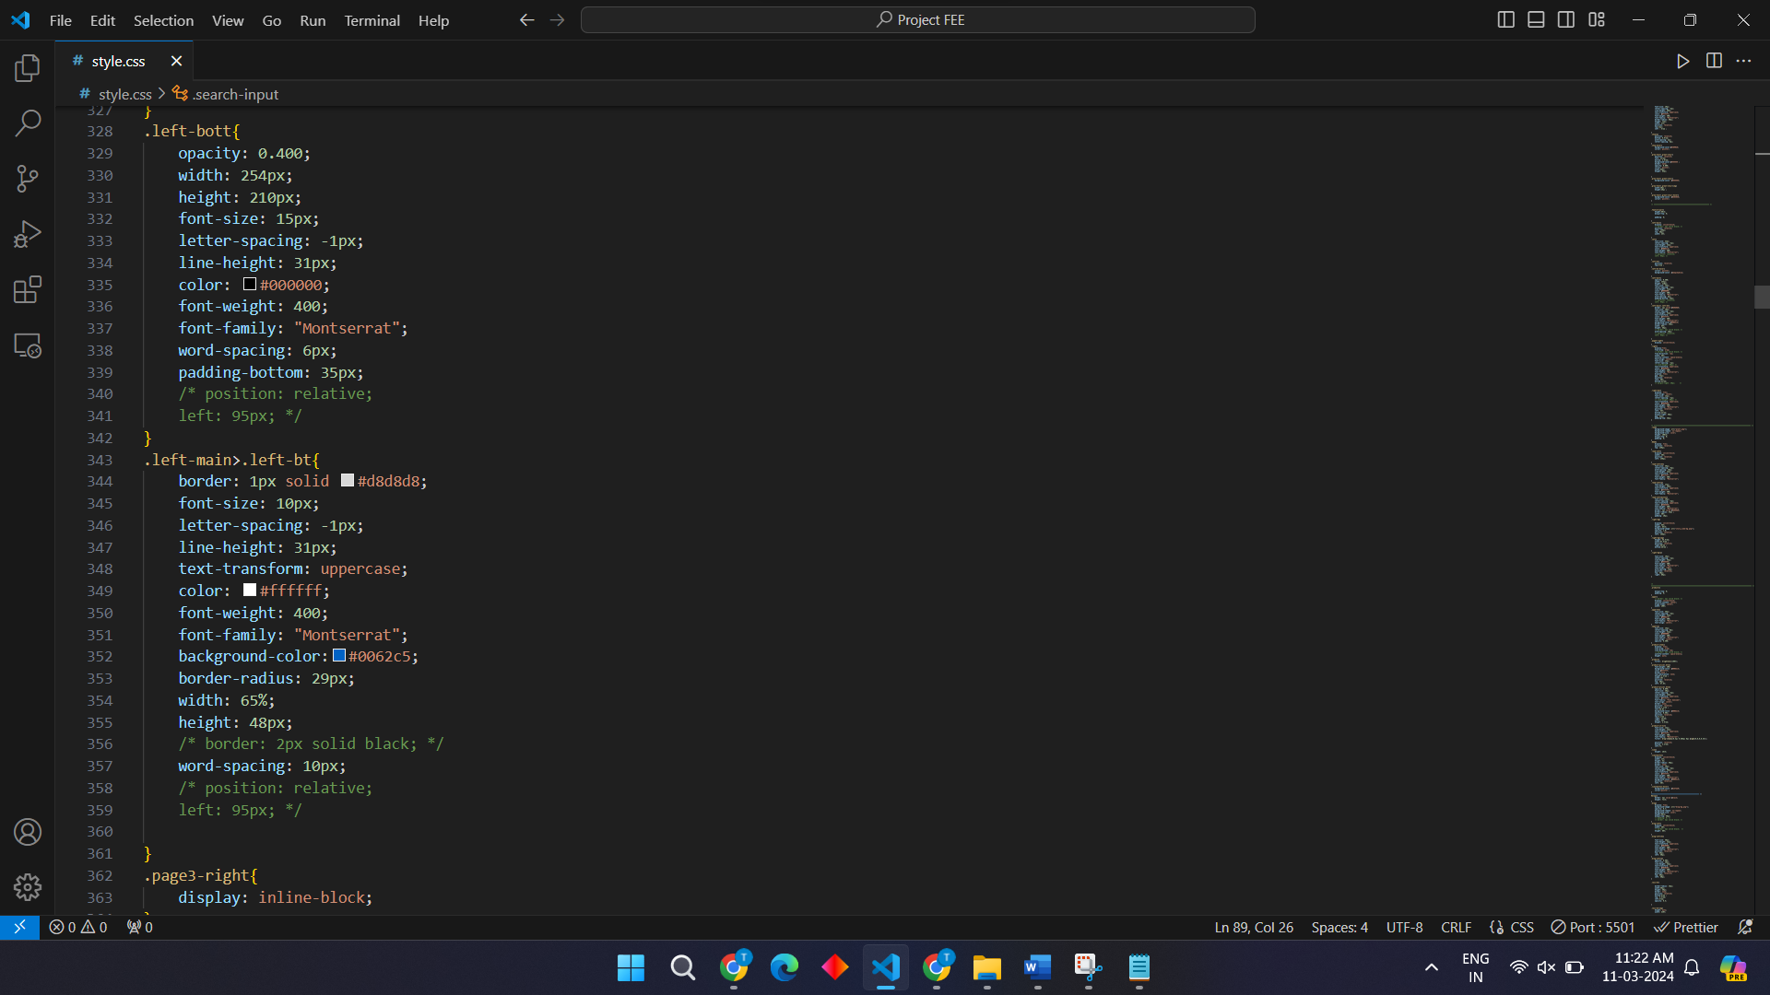

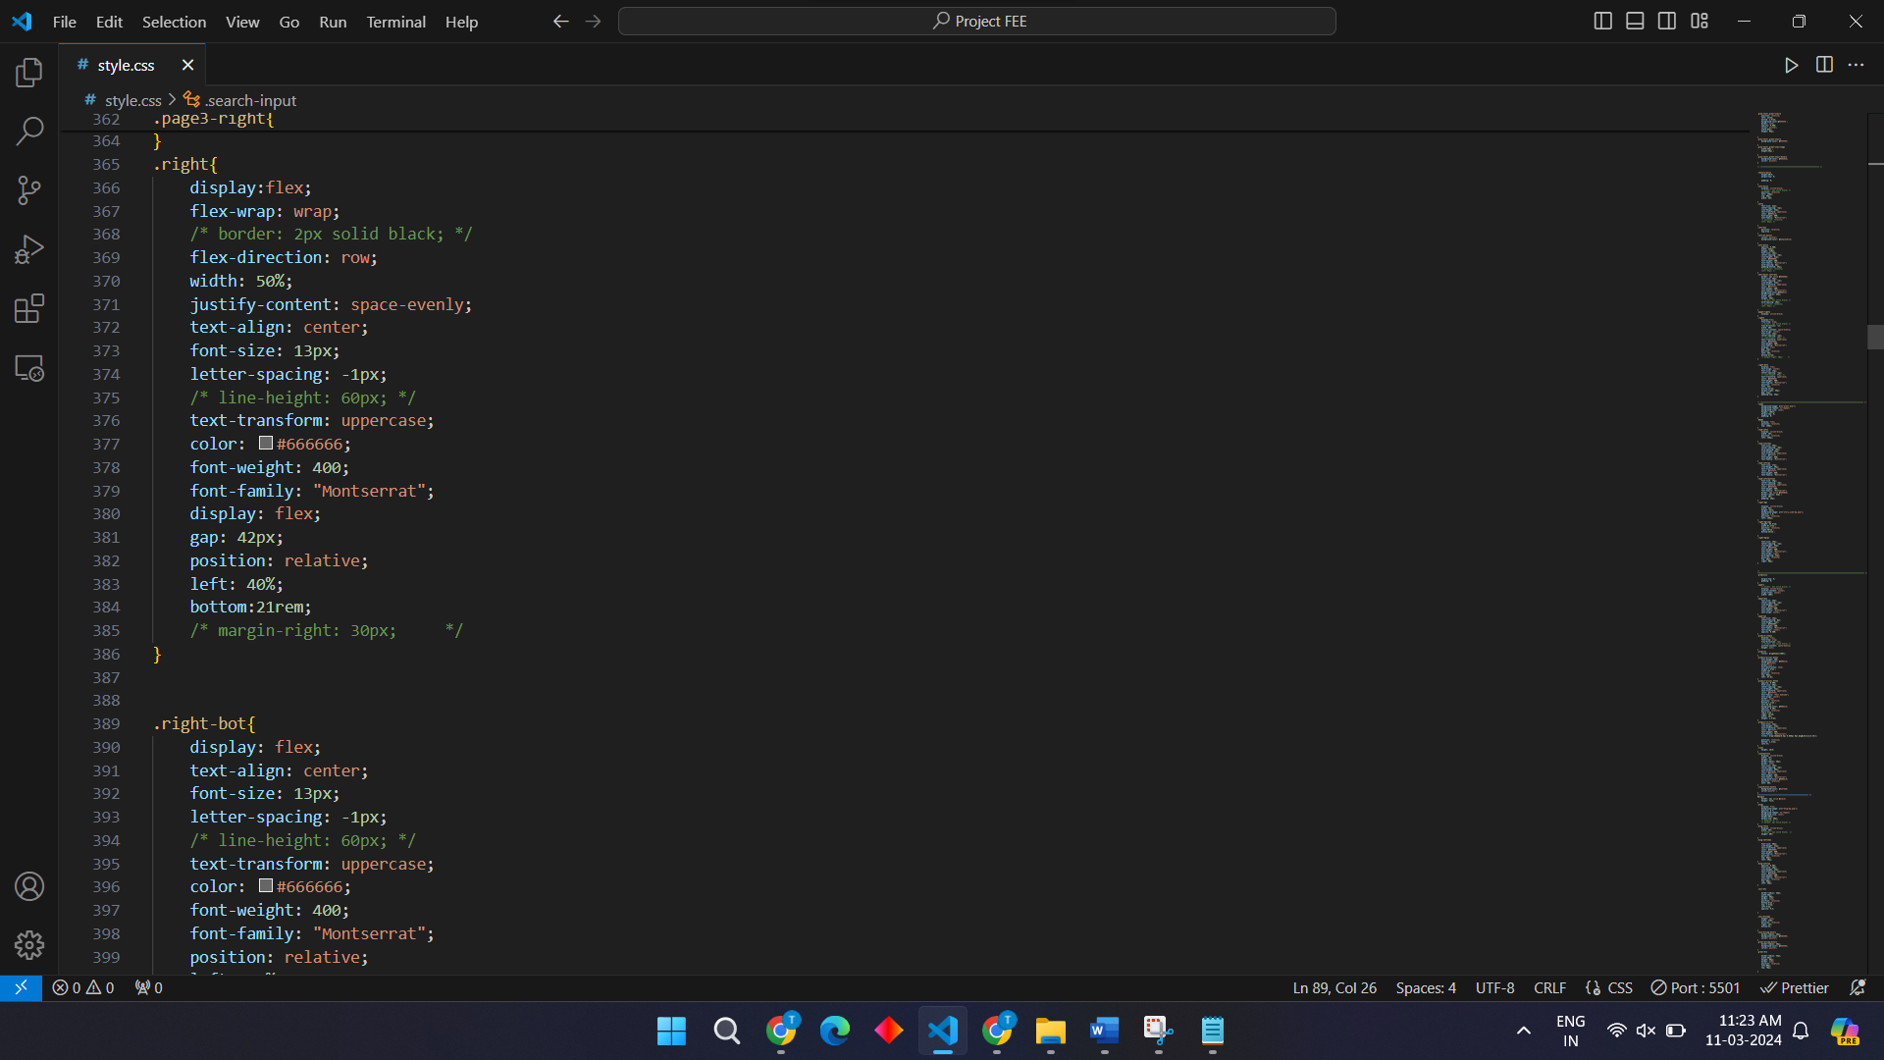

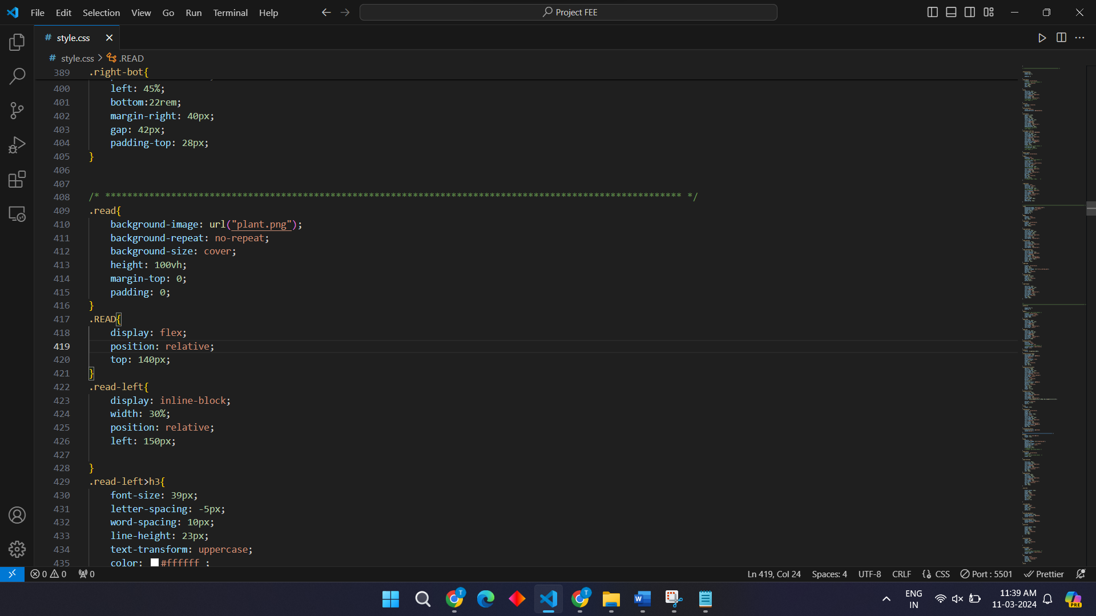

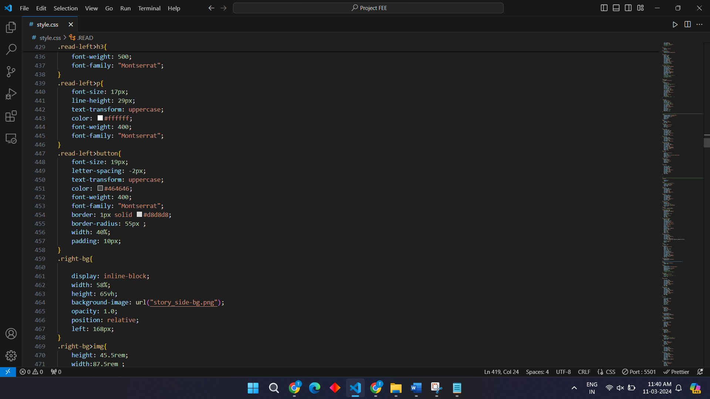

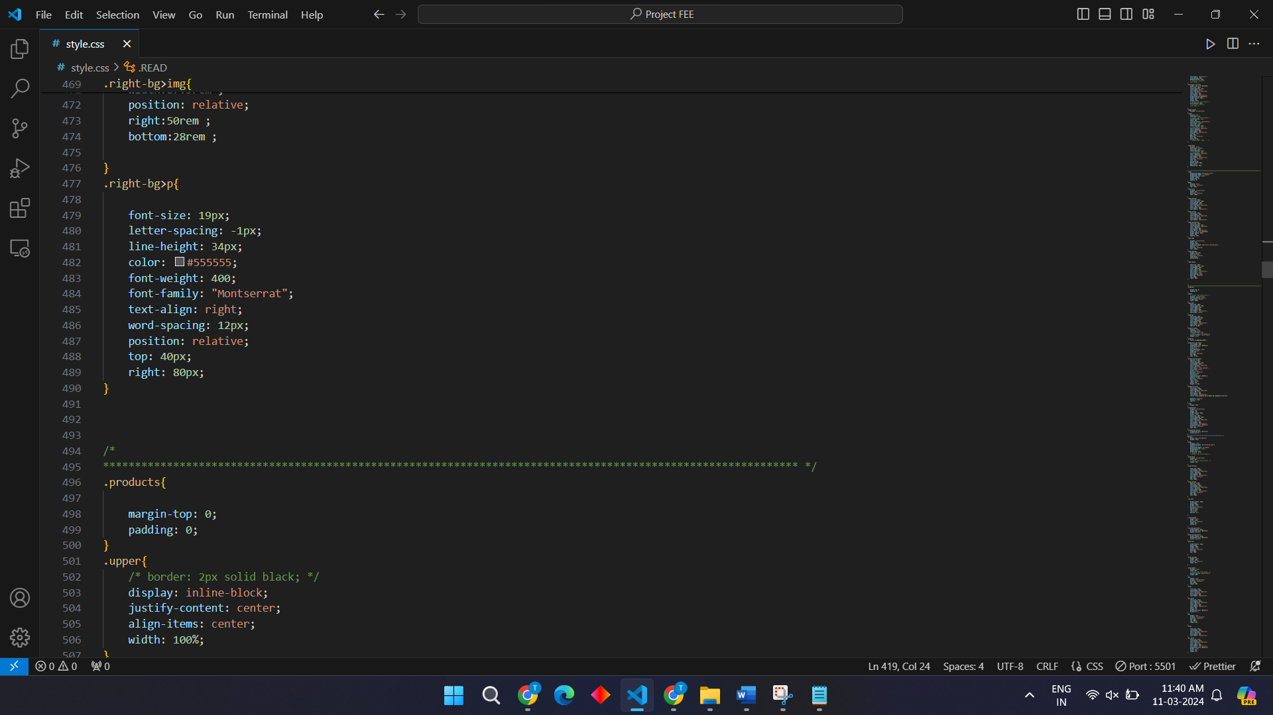

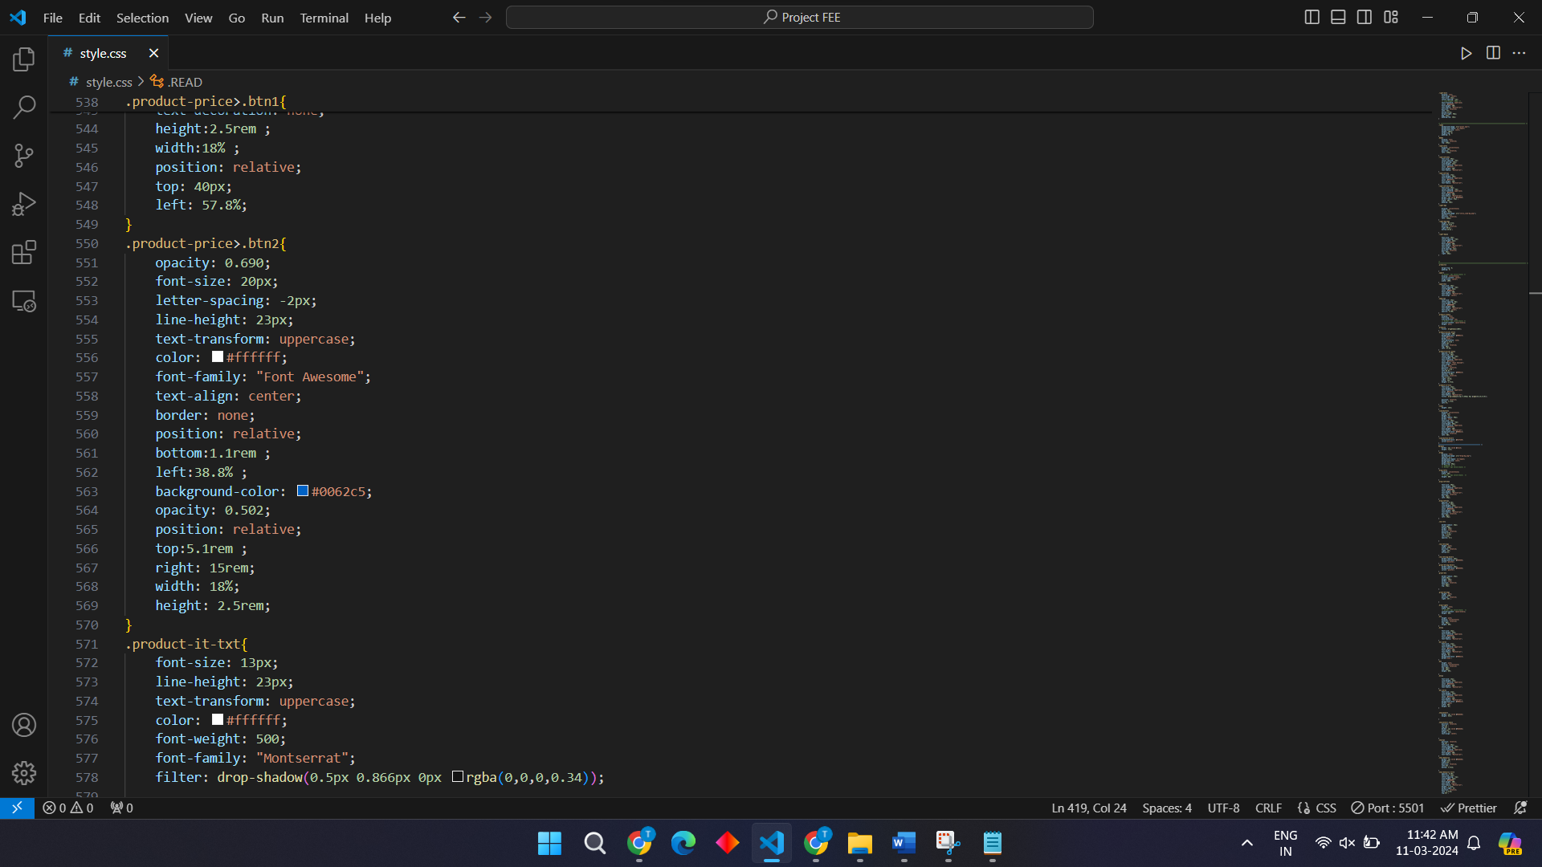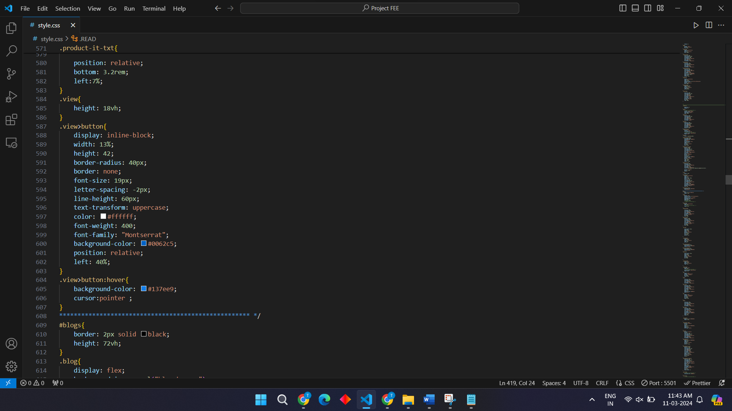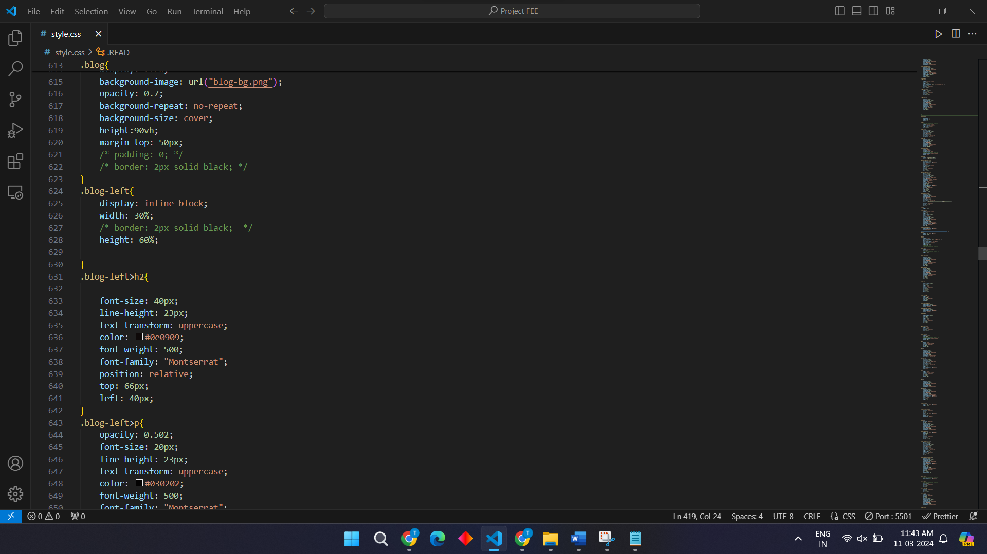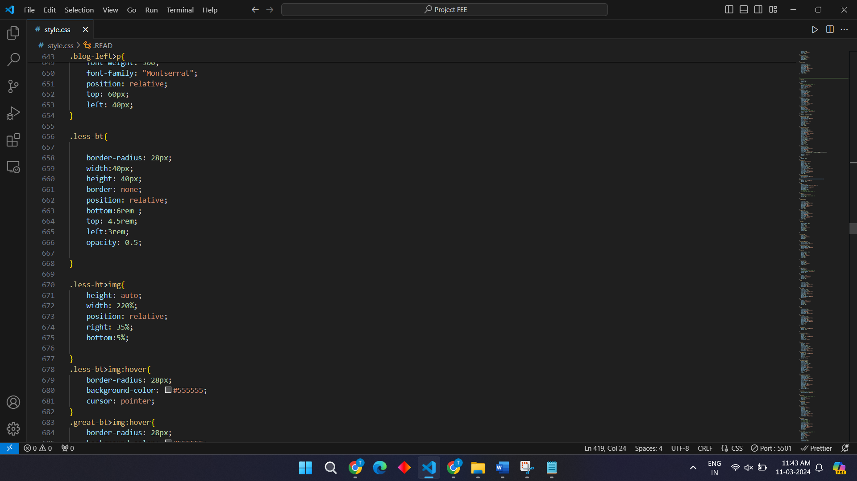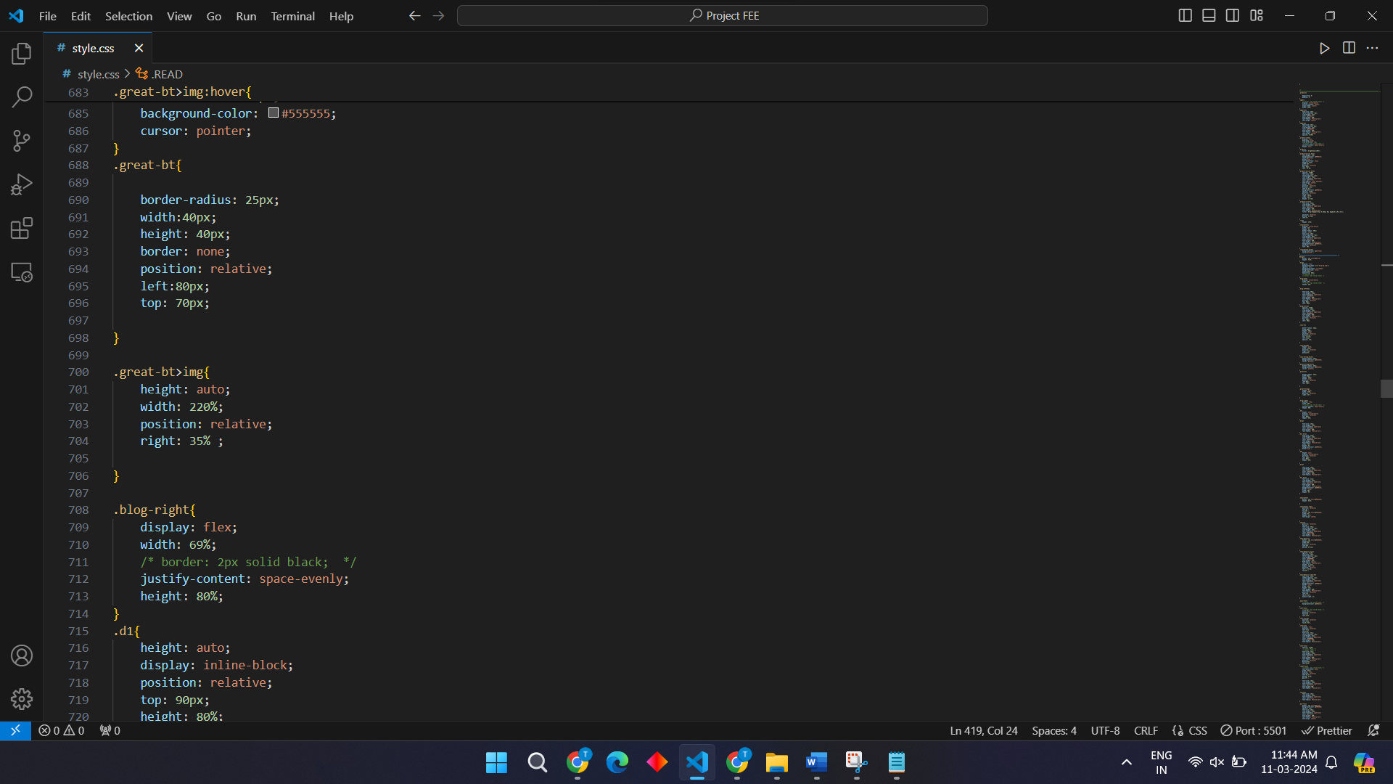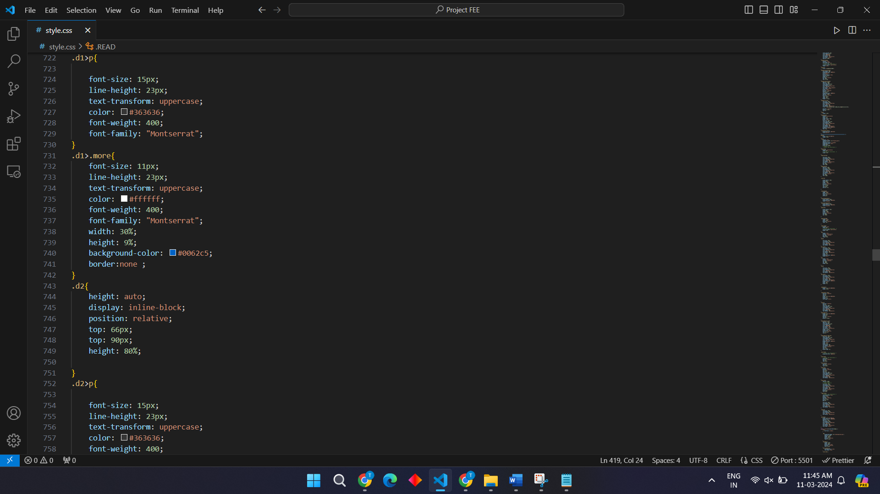

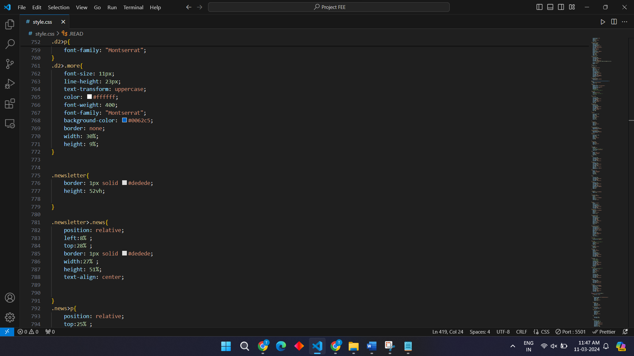

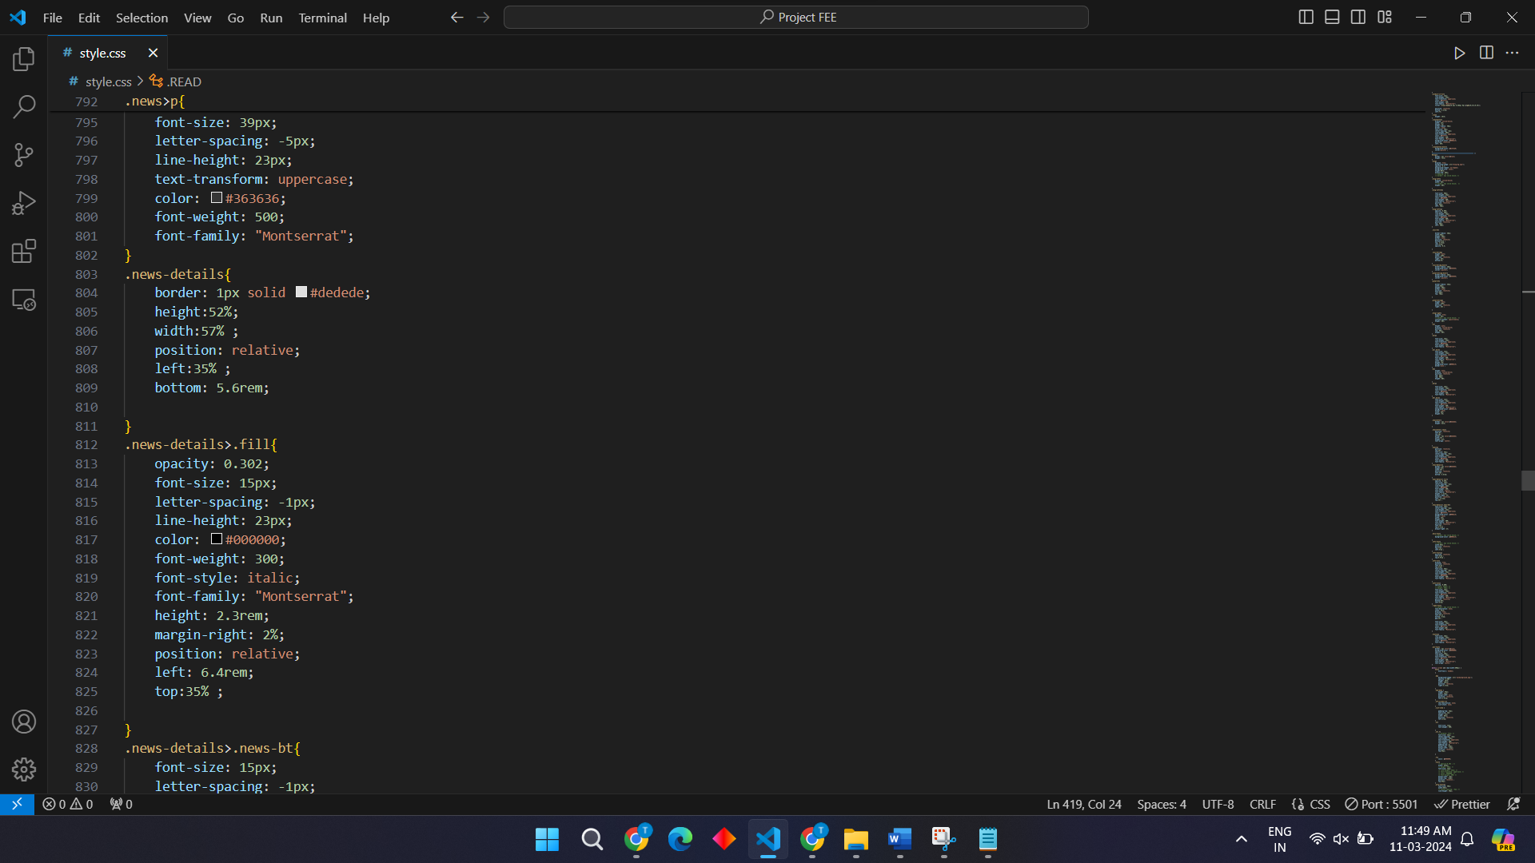

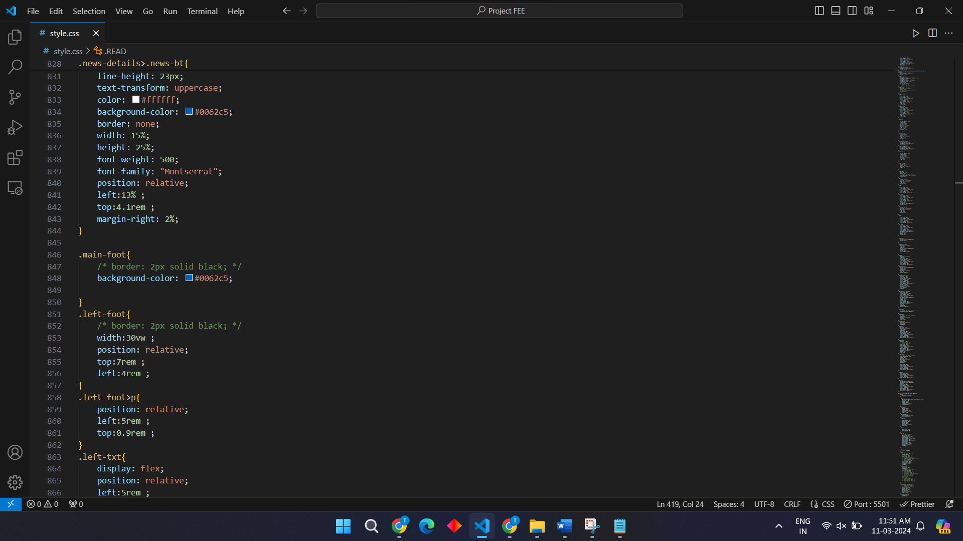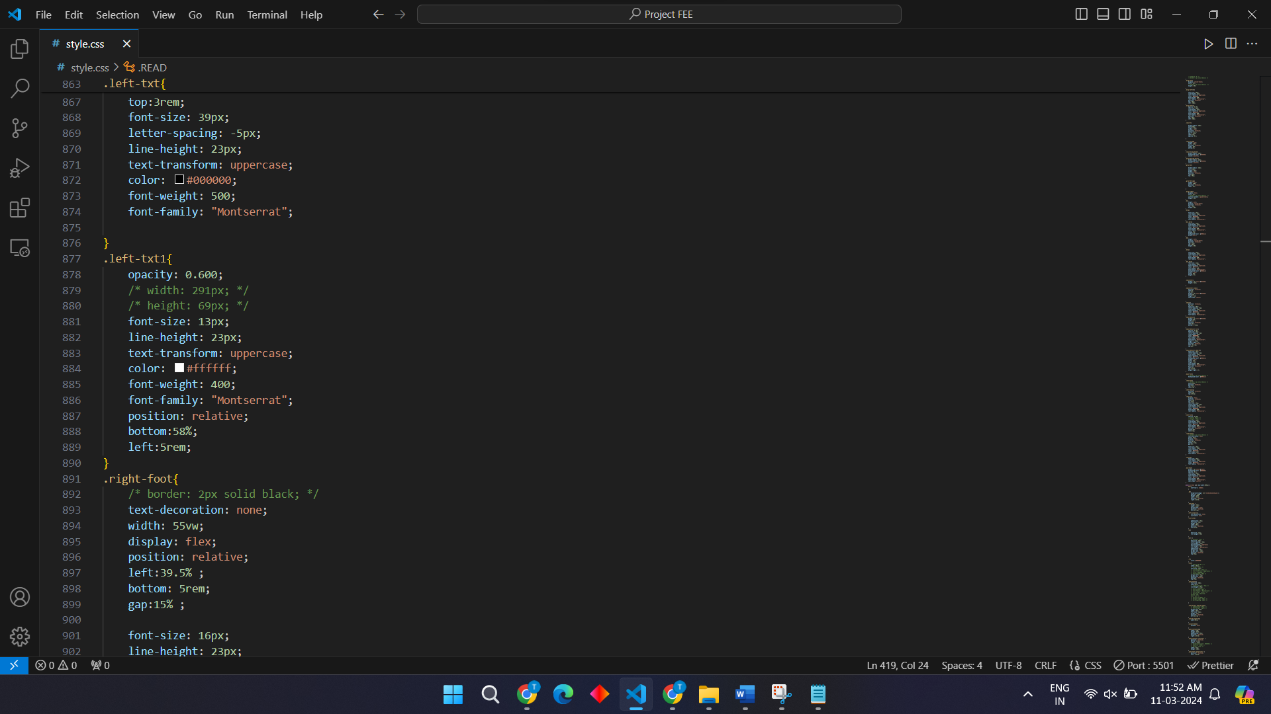

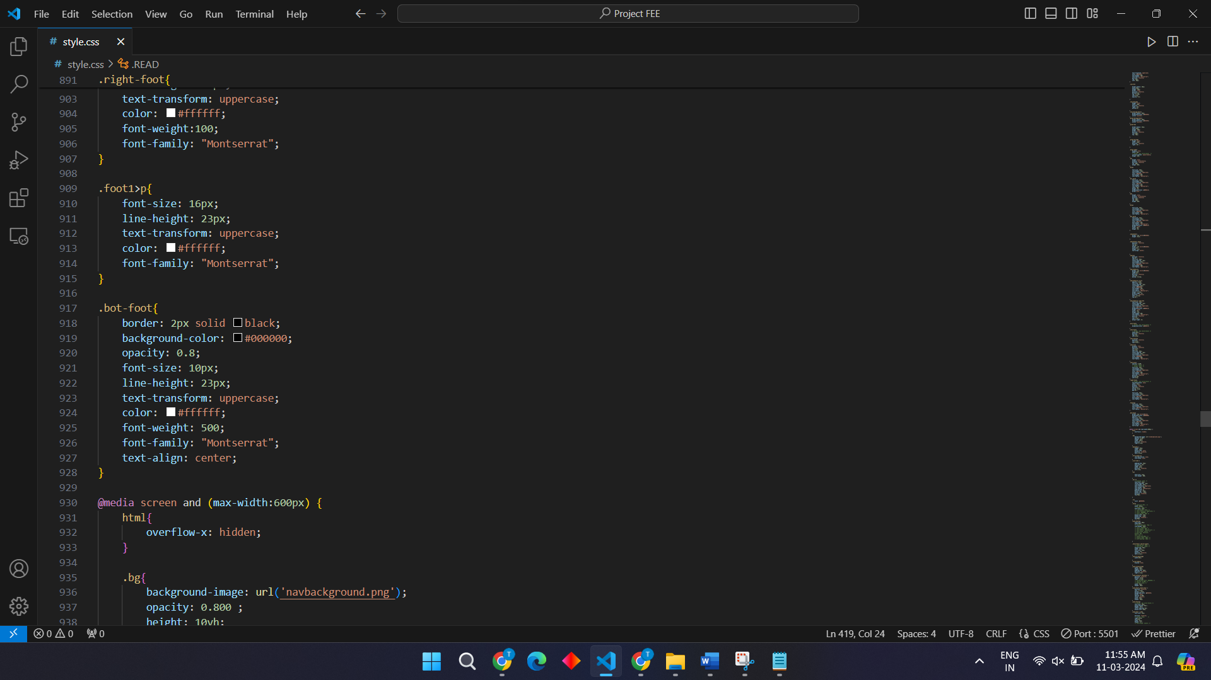

**CSS CODE : FOR MAX WIDTH:600**

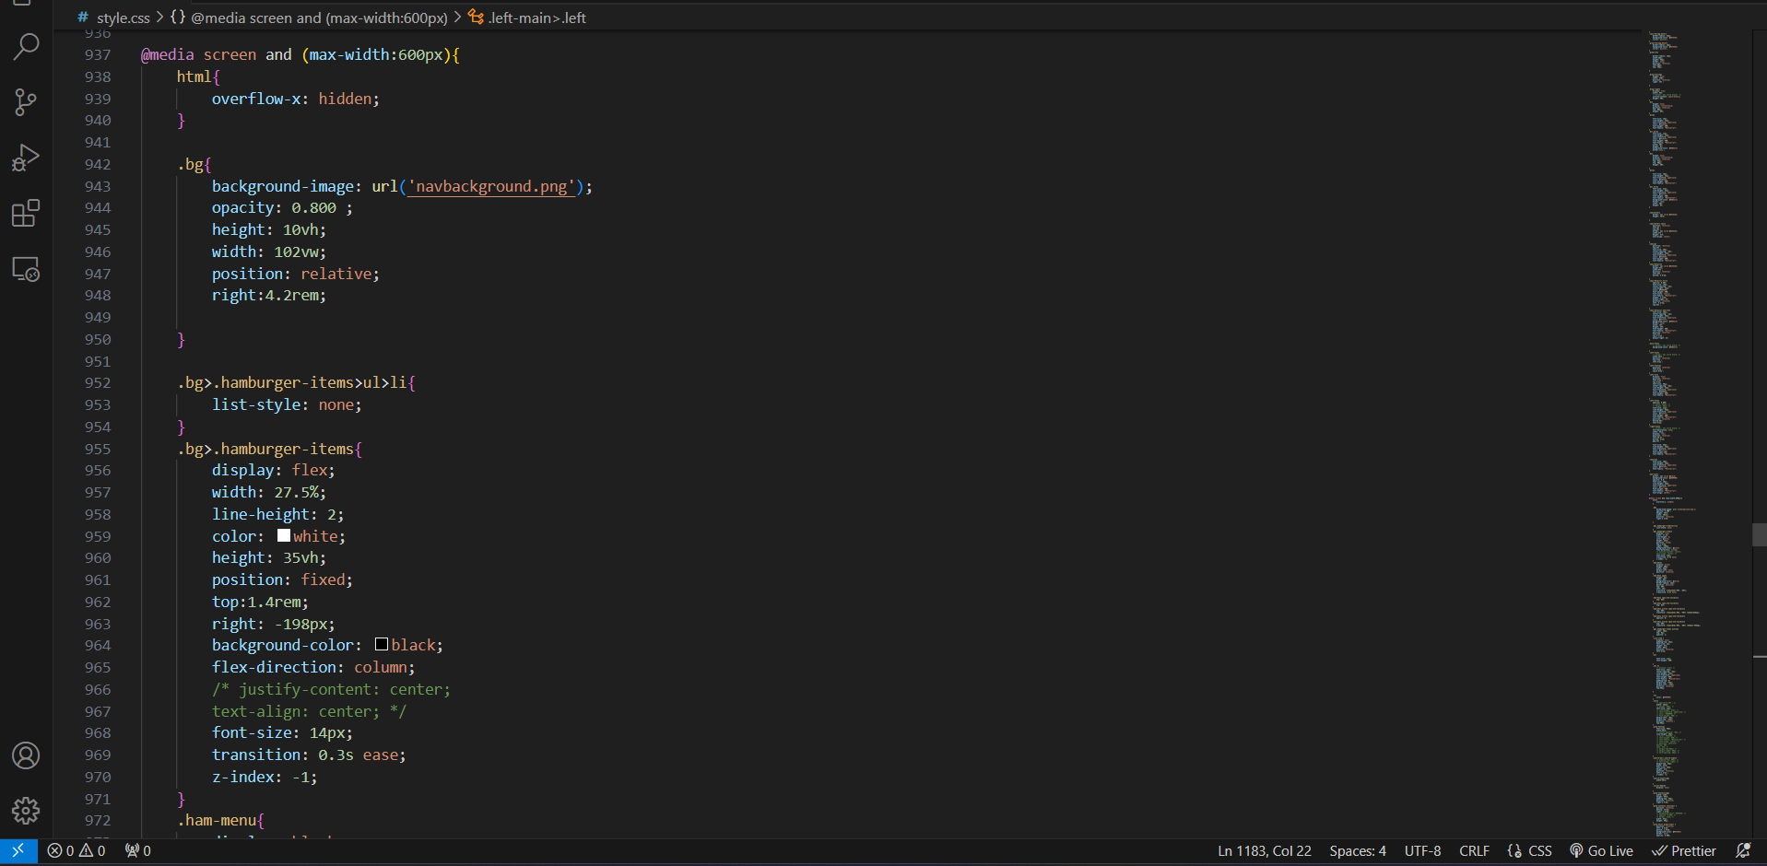

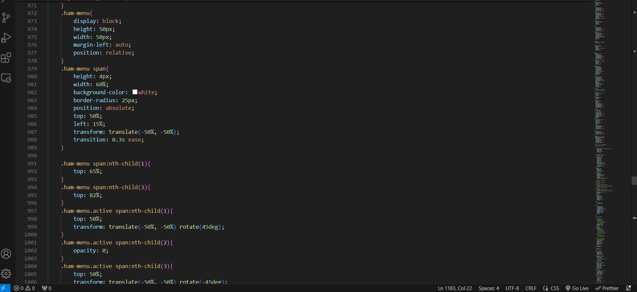

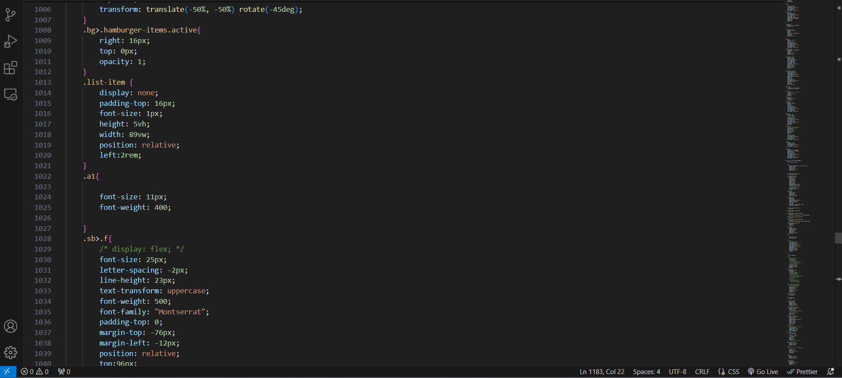

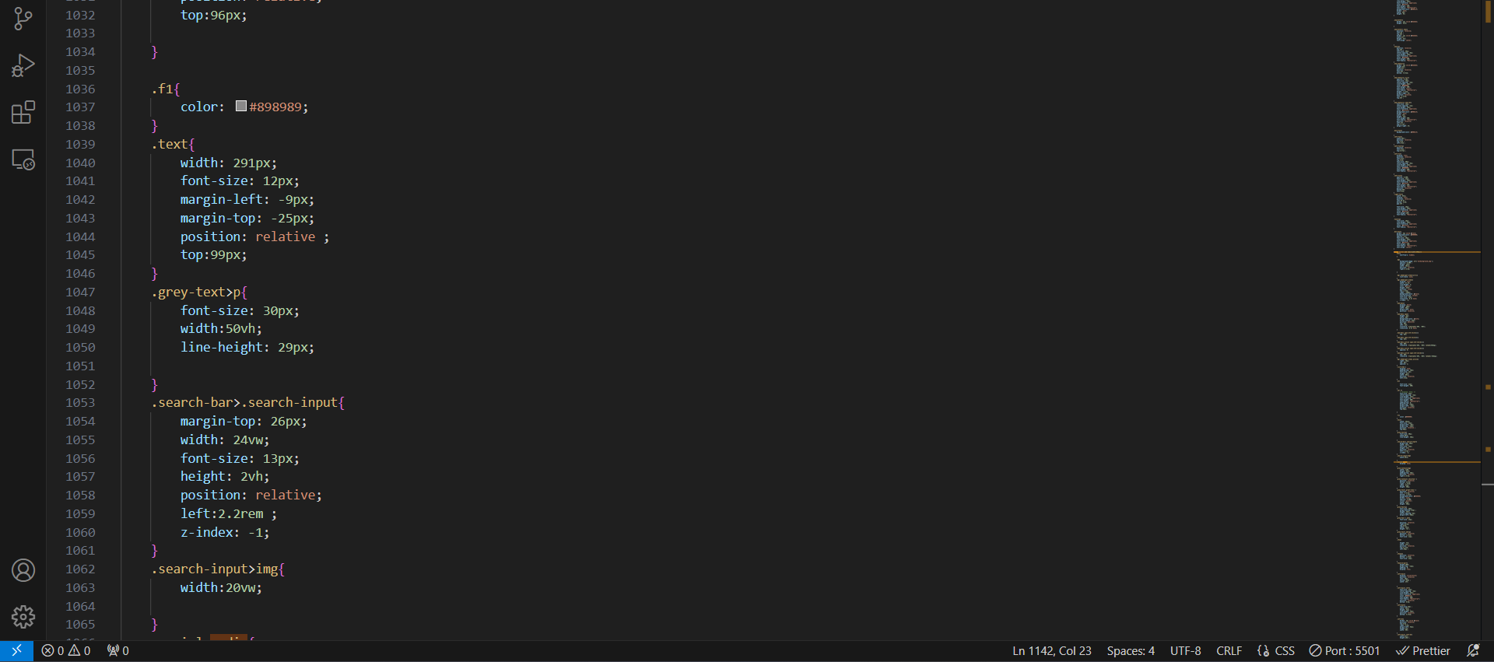

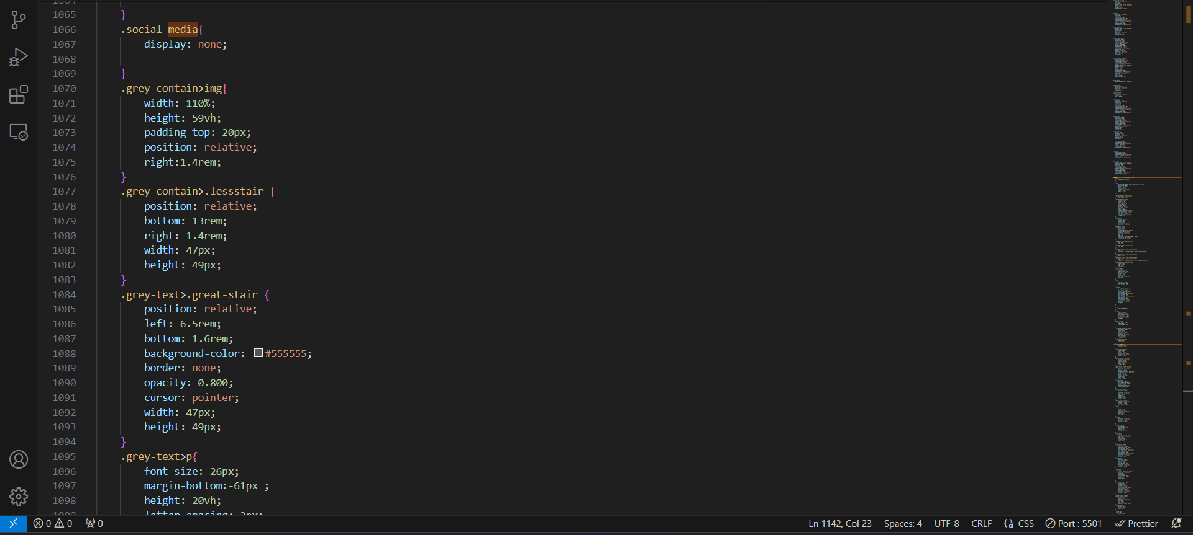

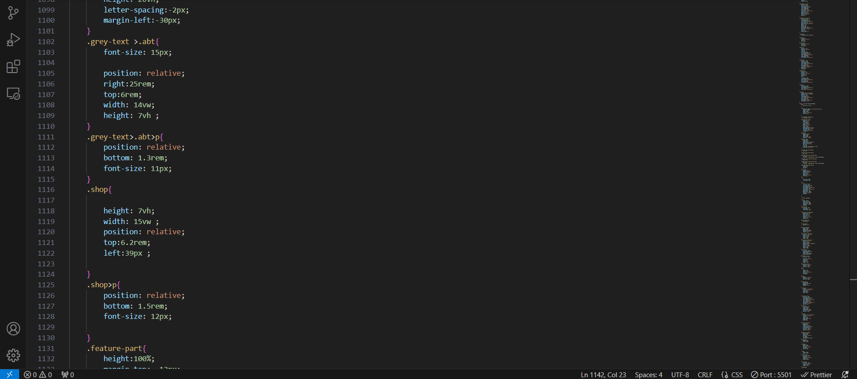

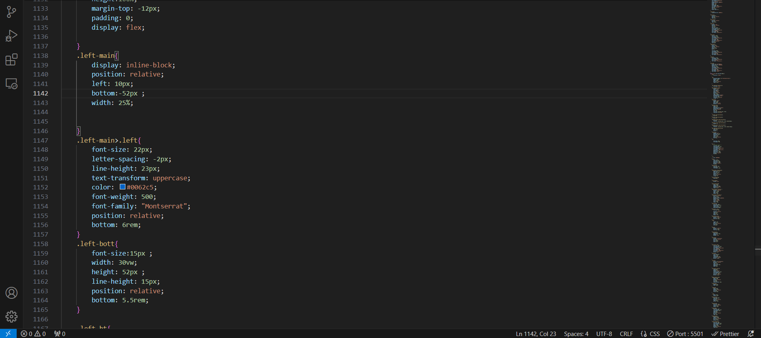

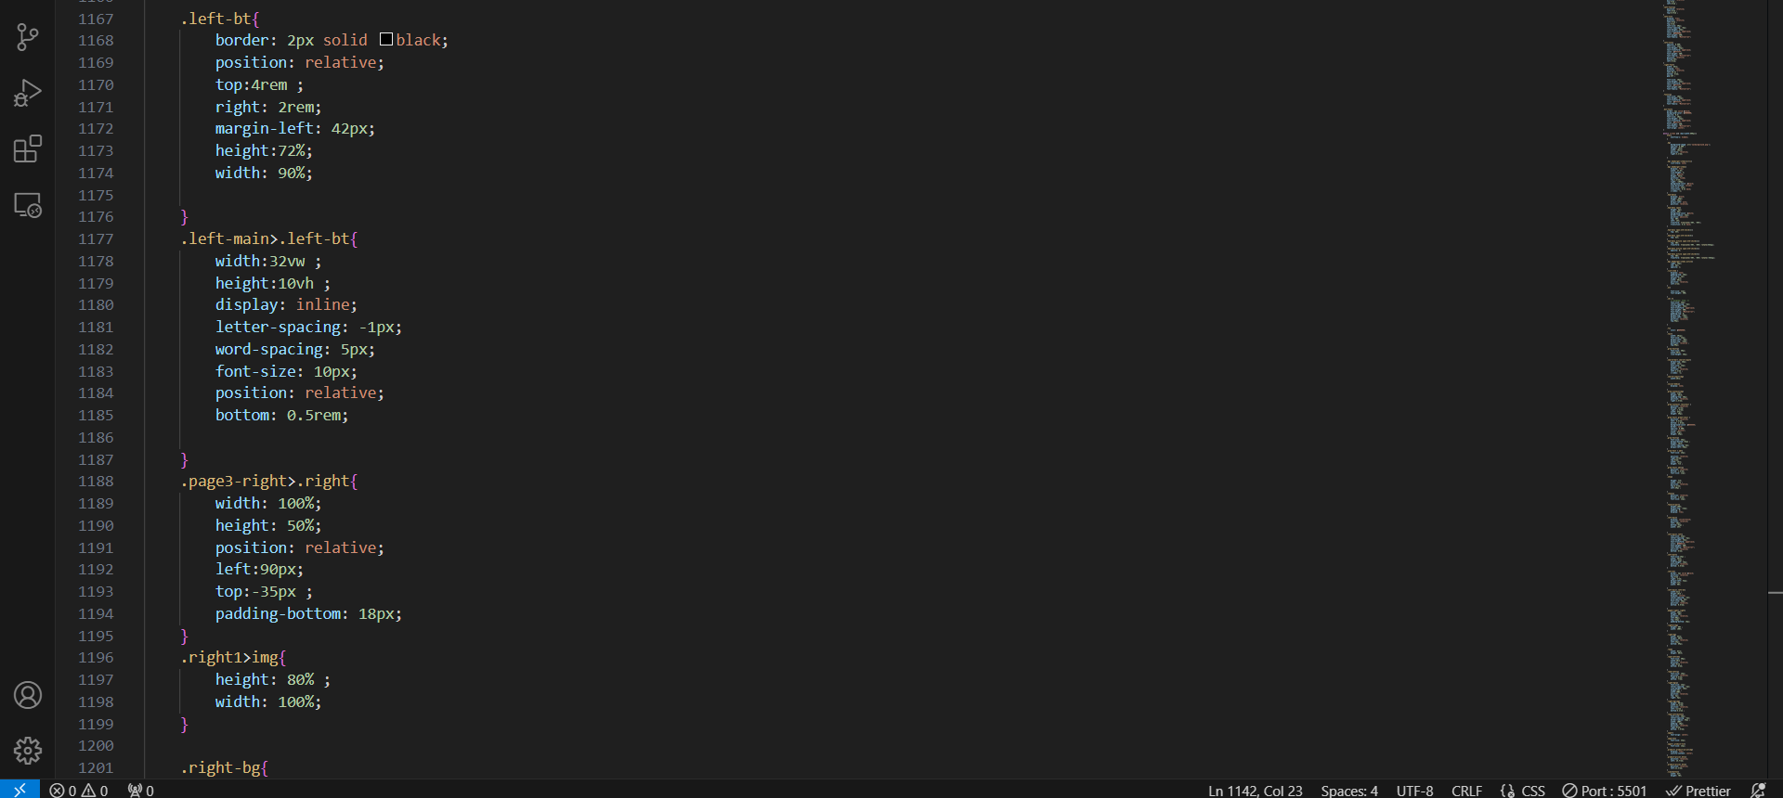

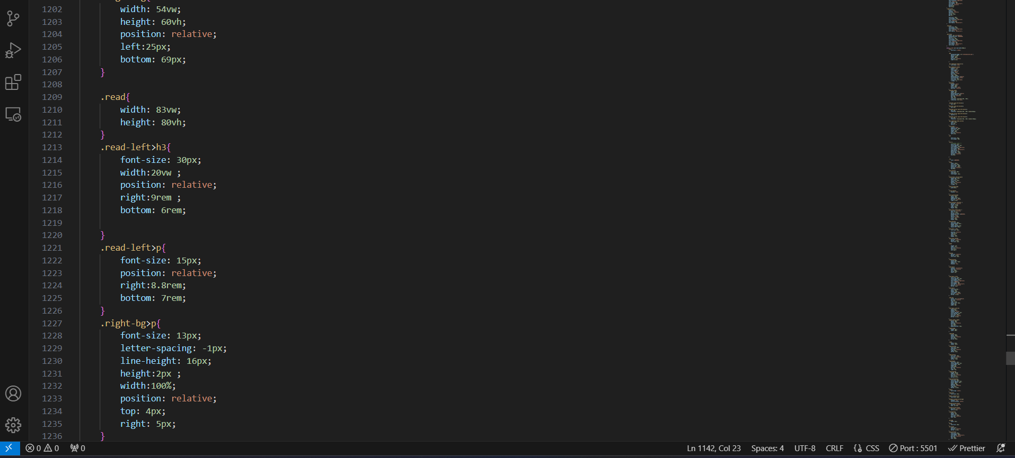

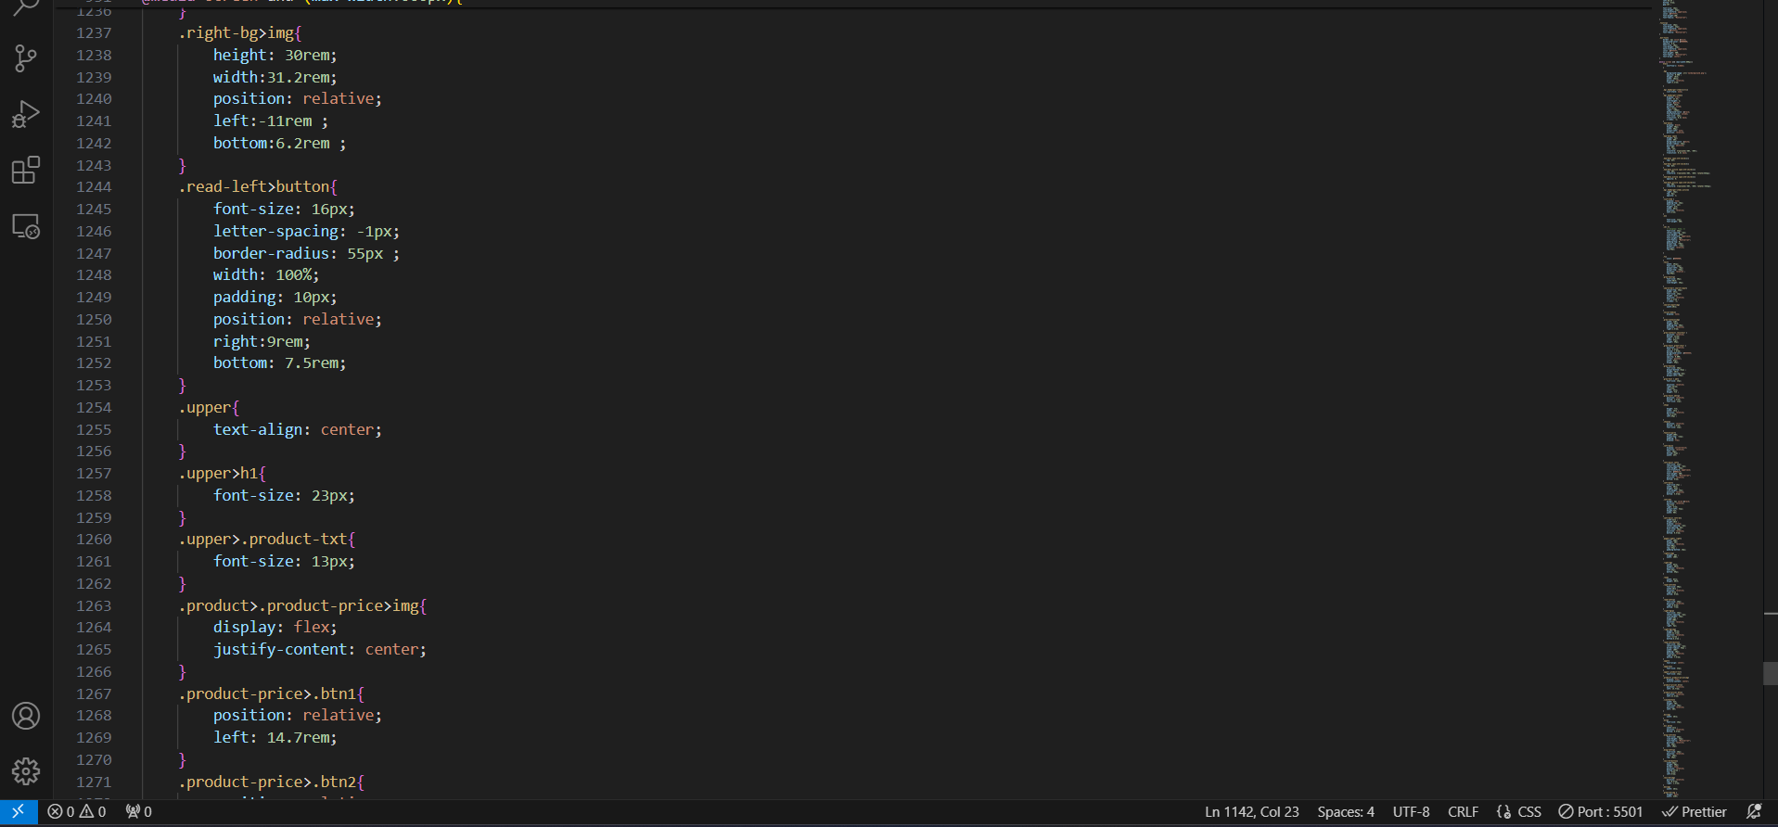

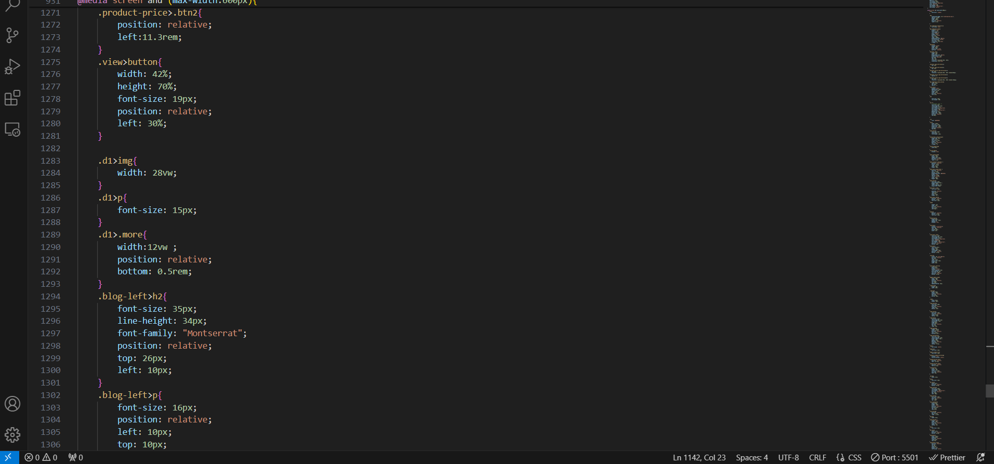

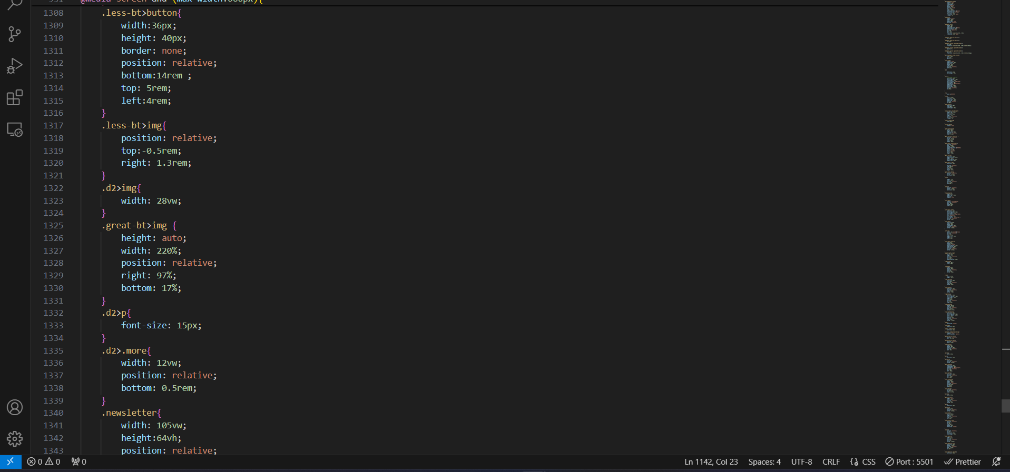

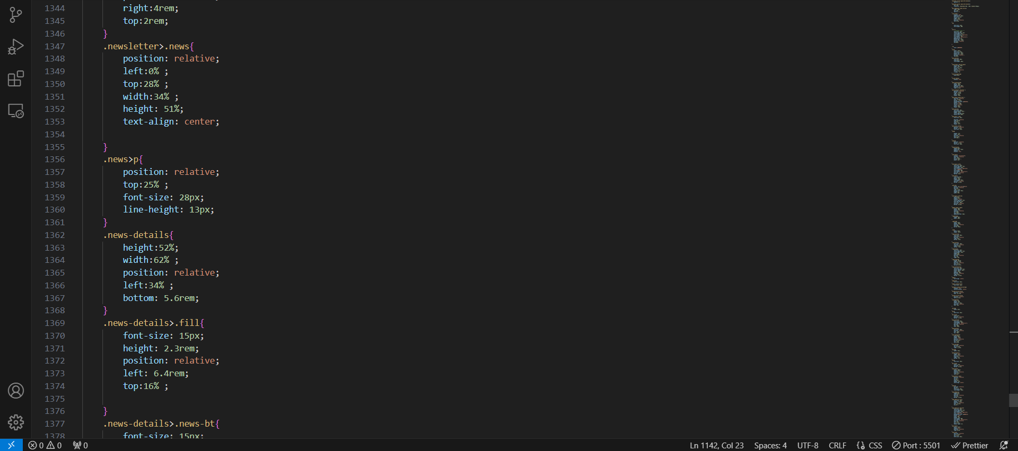

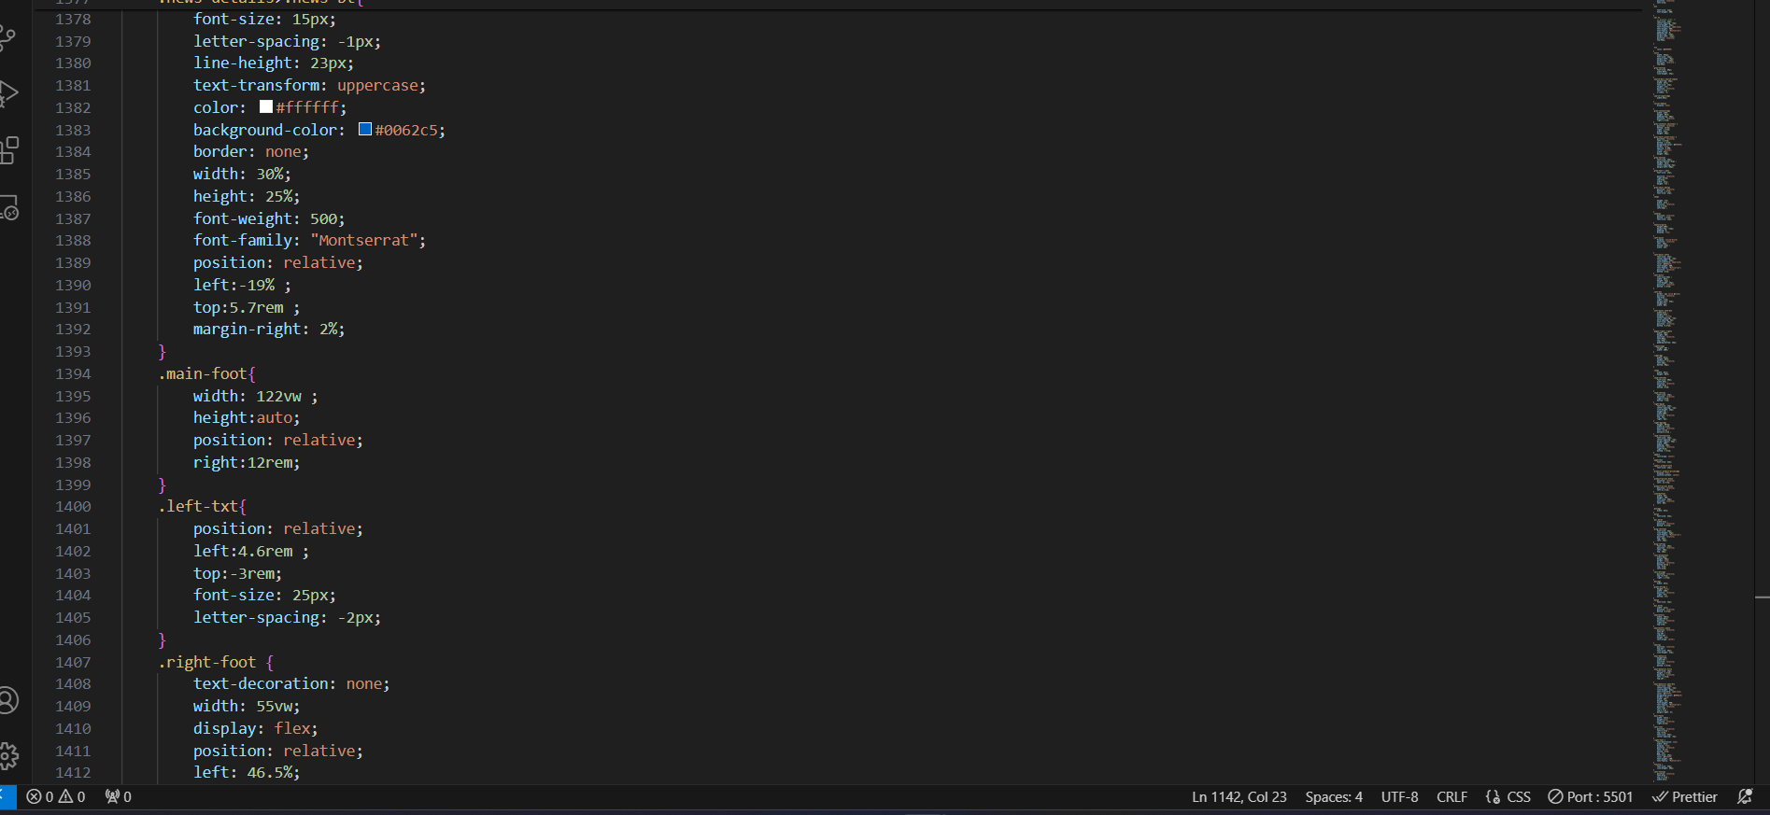

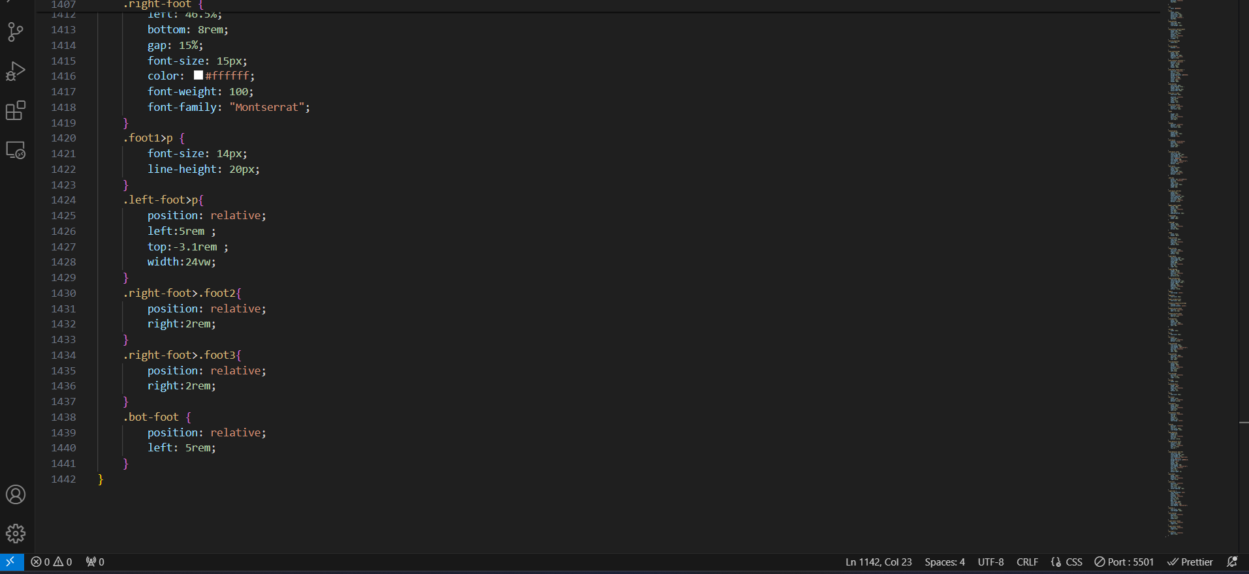

**RESULT:**

**DESKTOP**

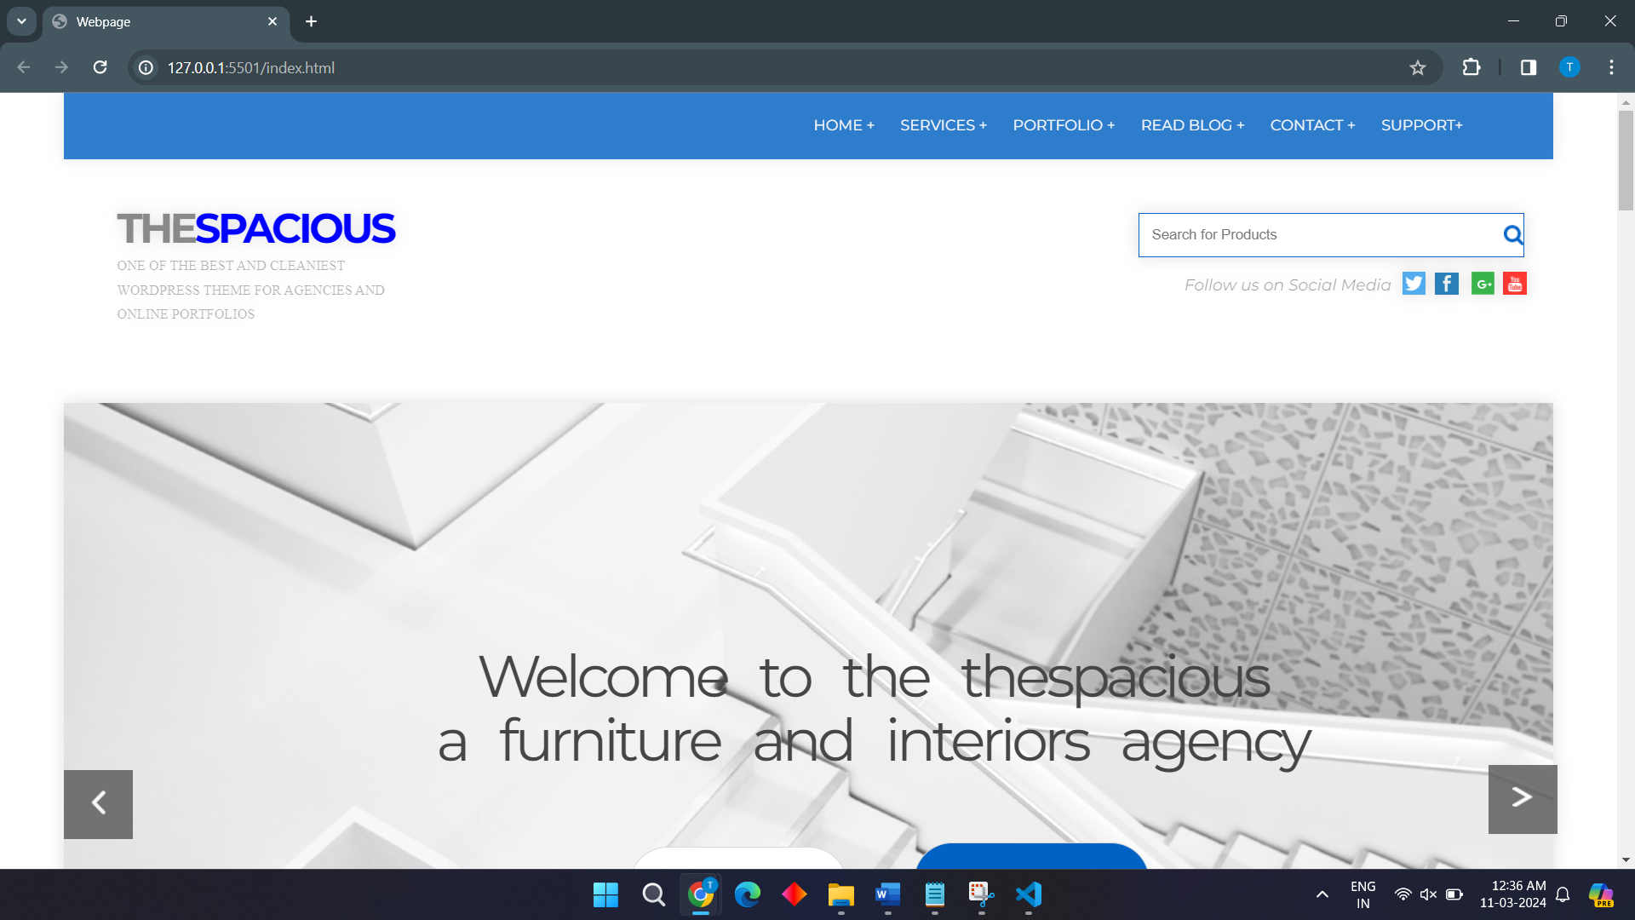

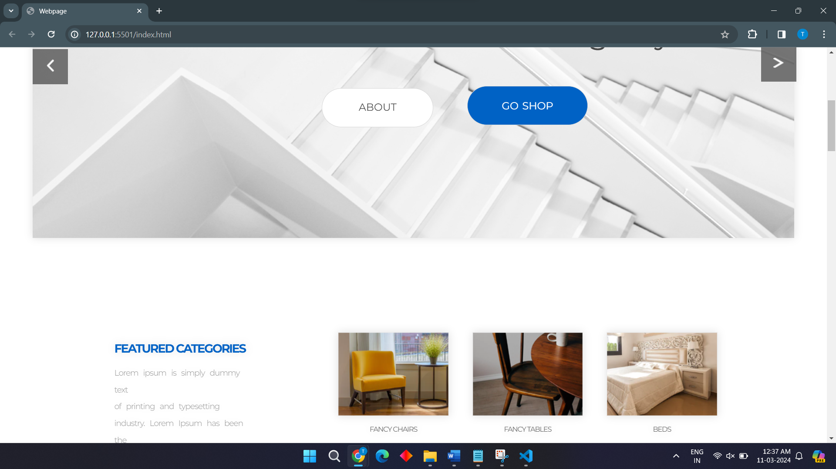

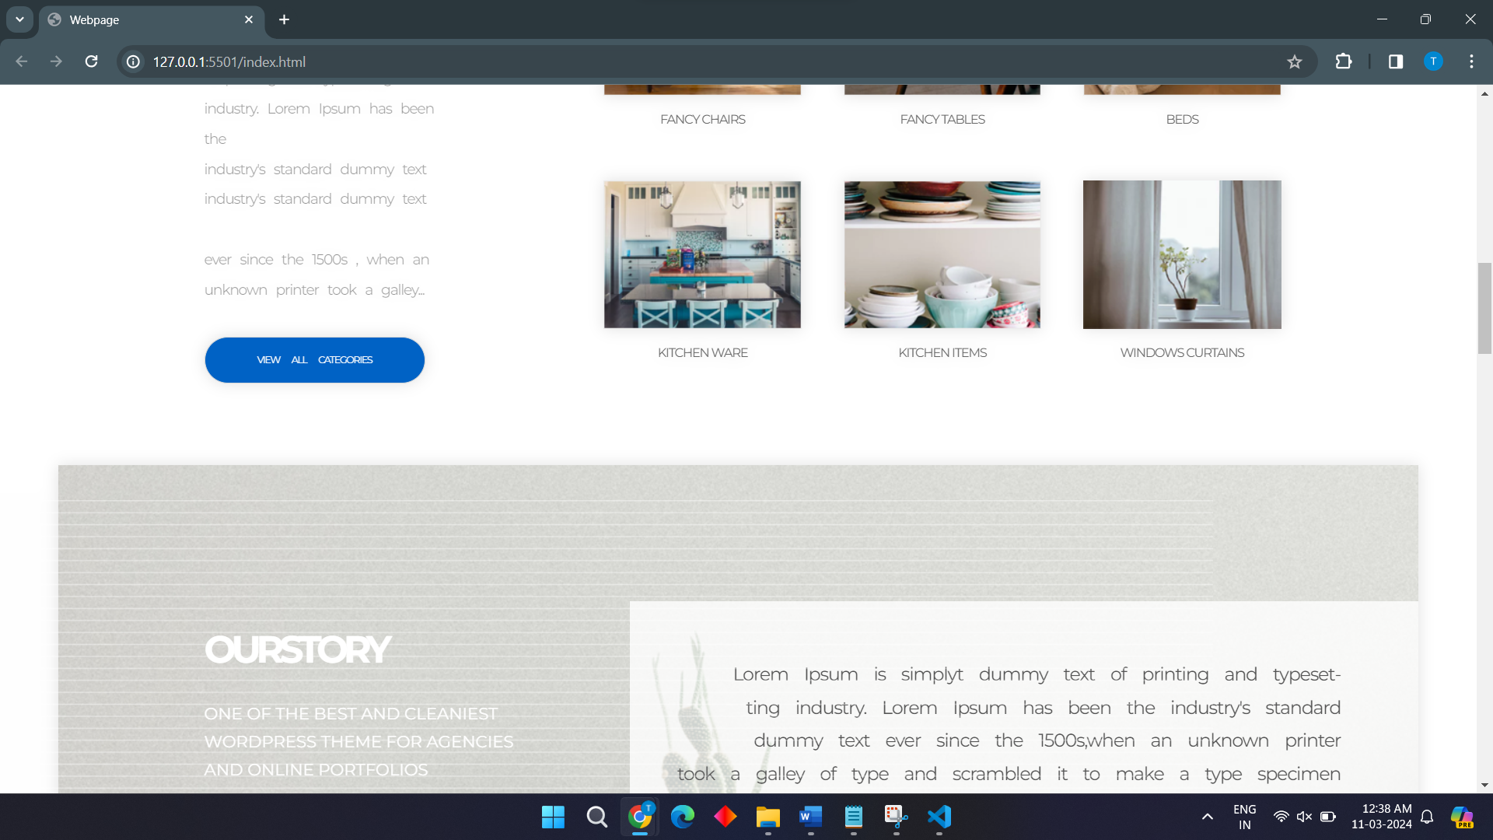

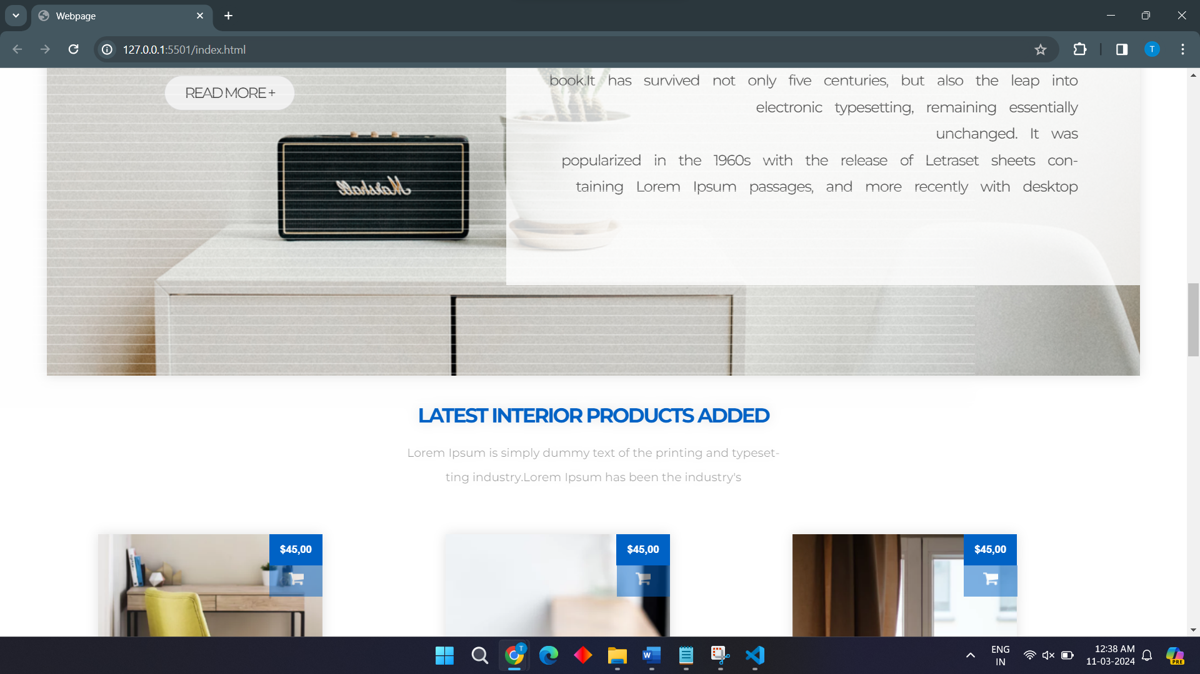

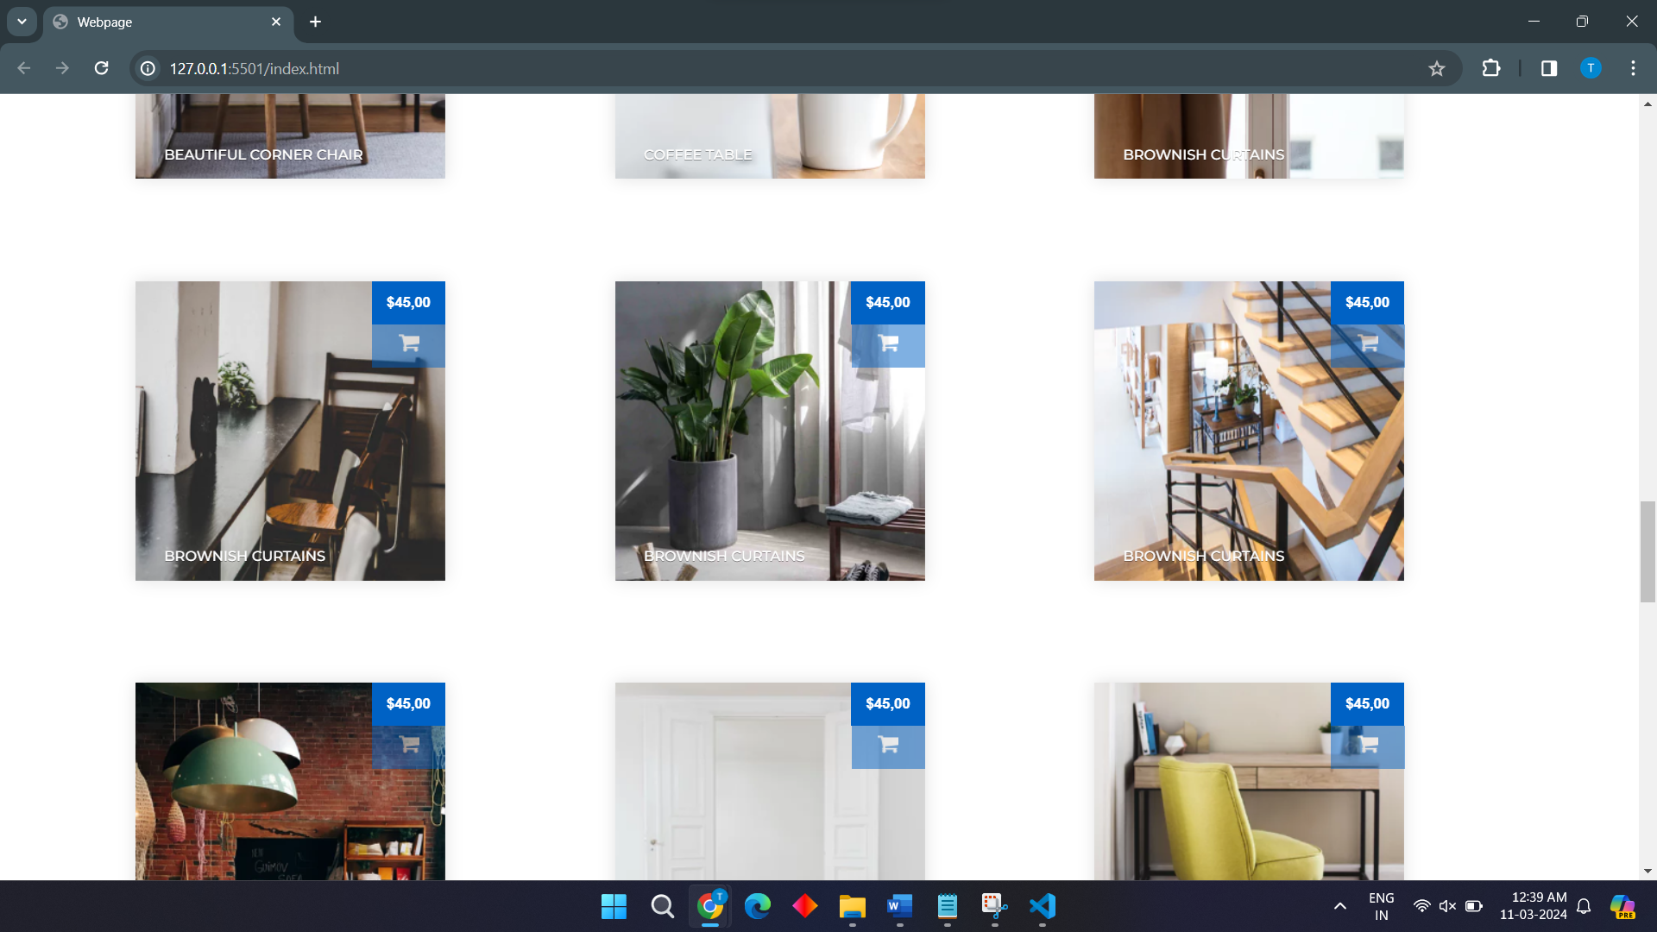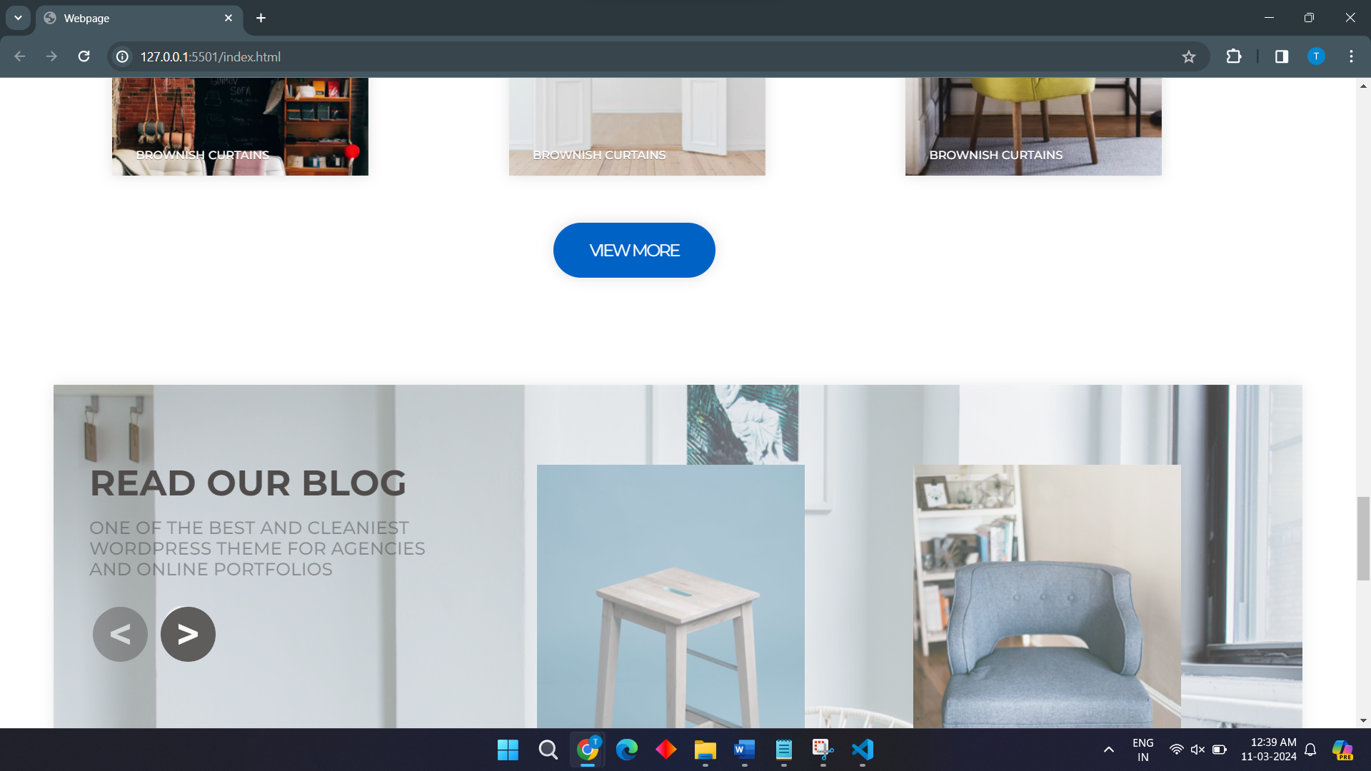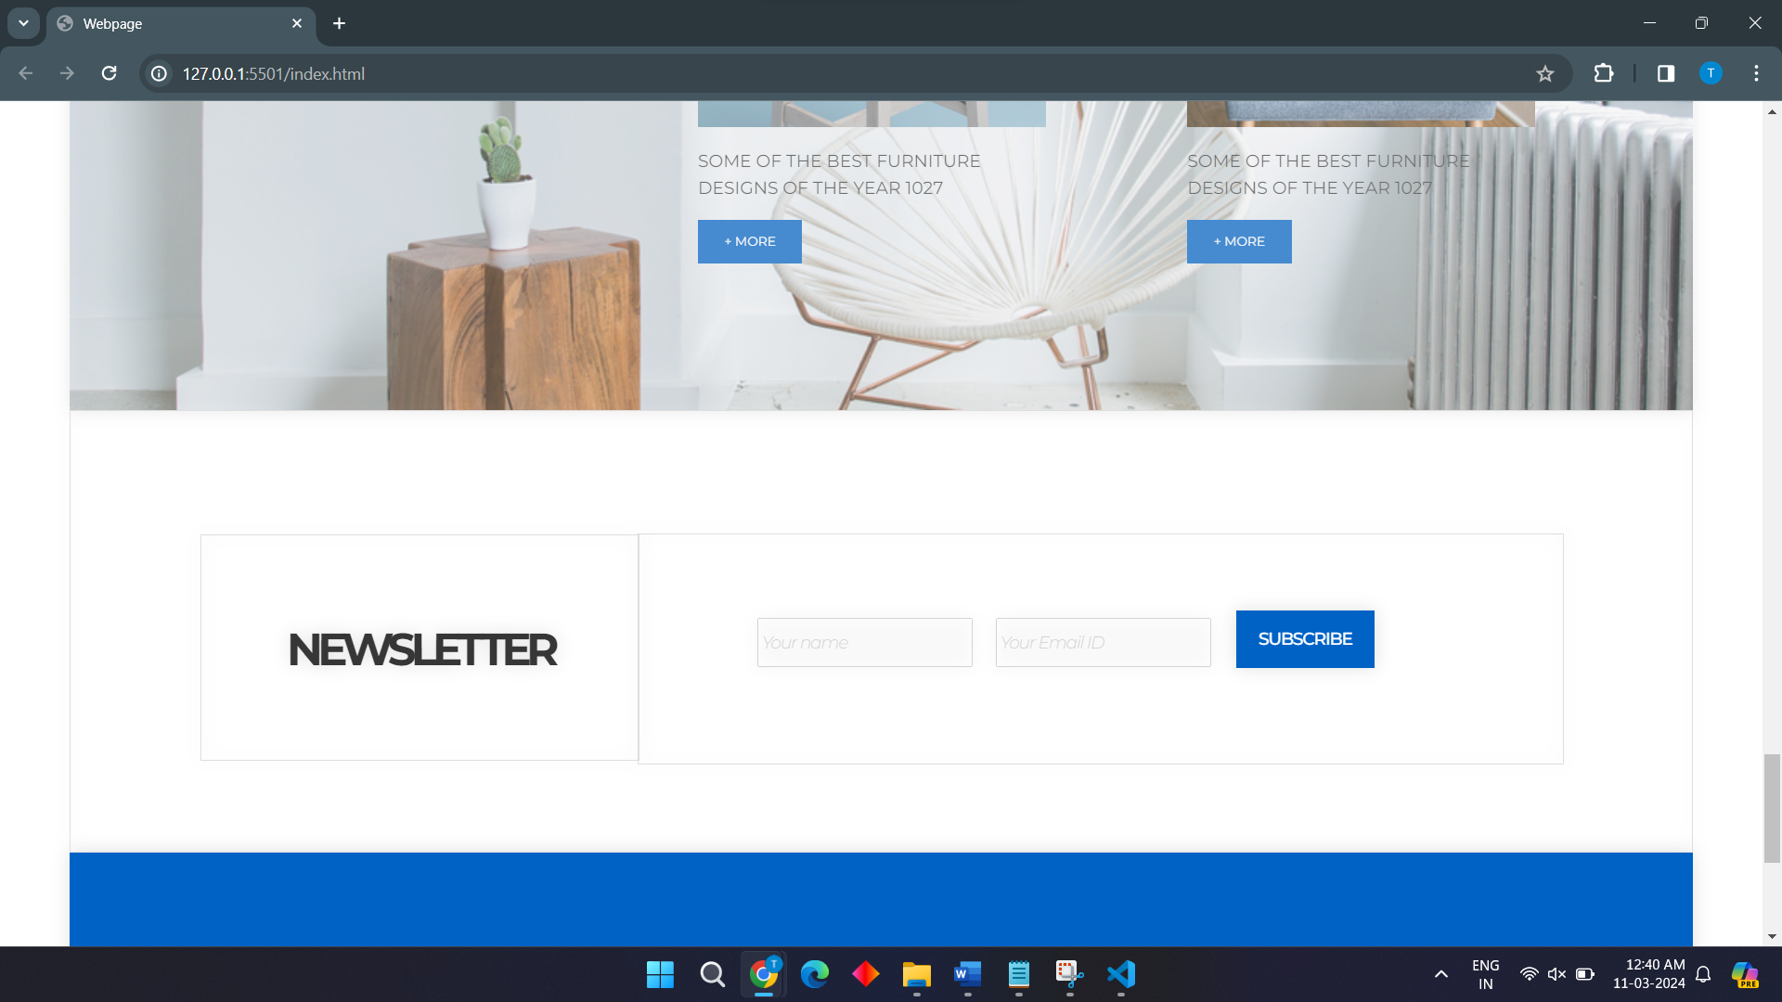

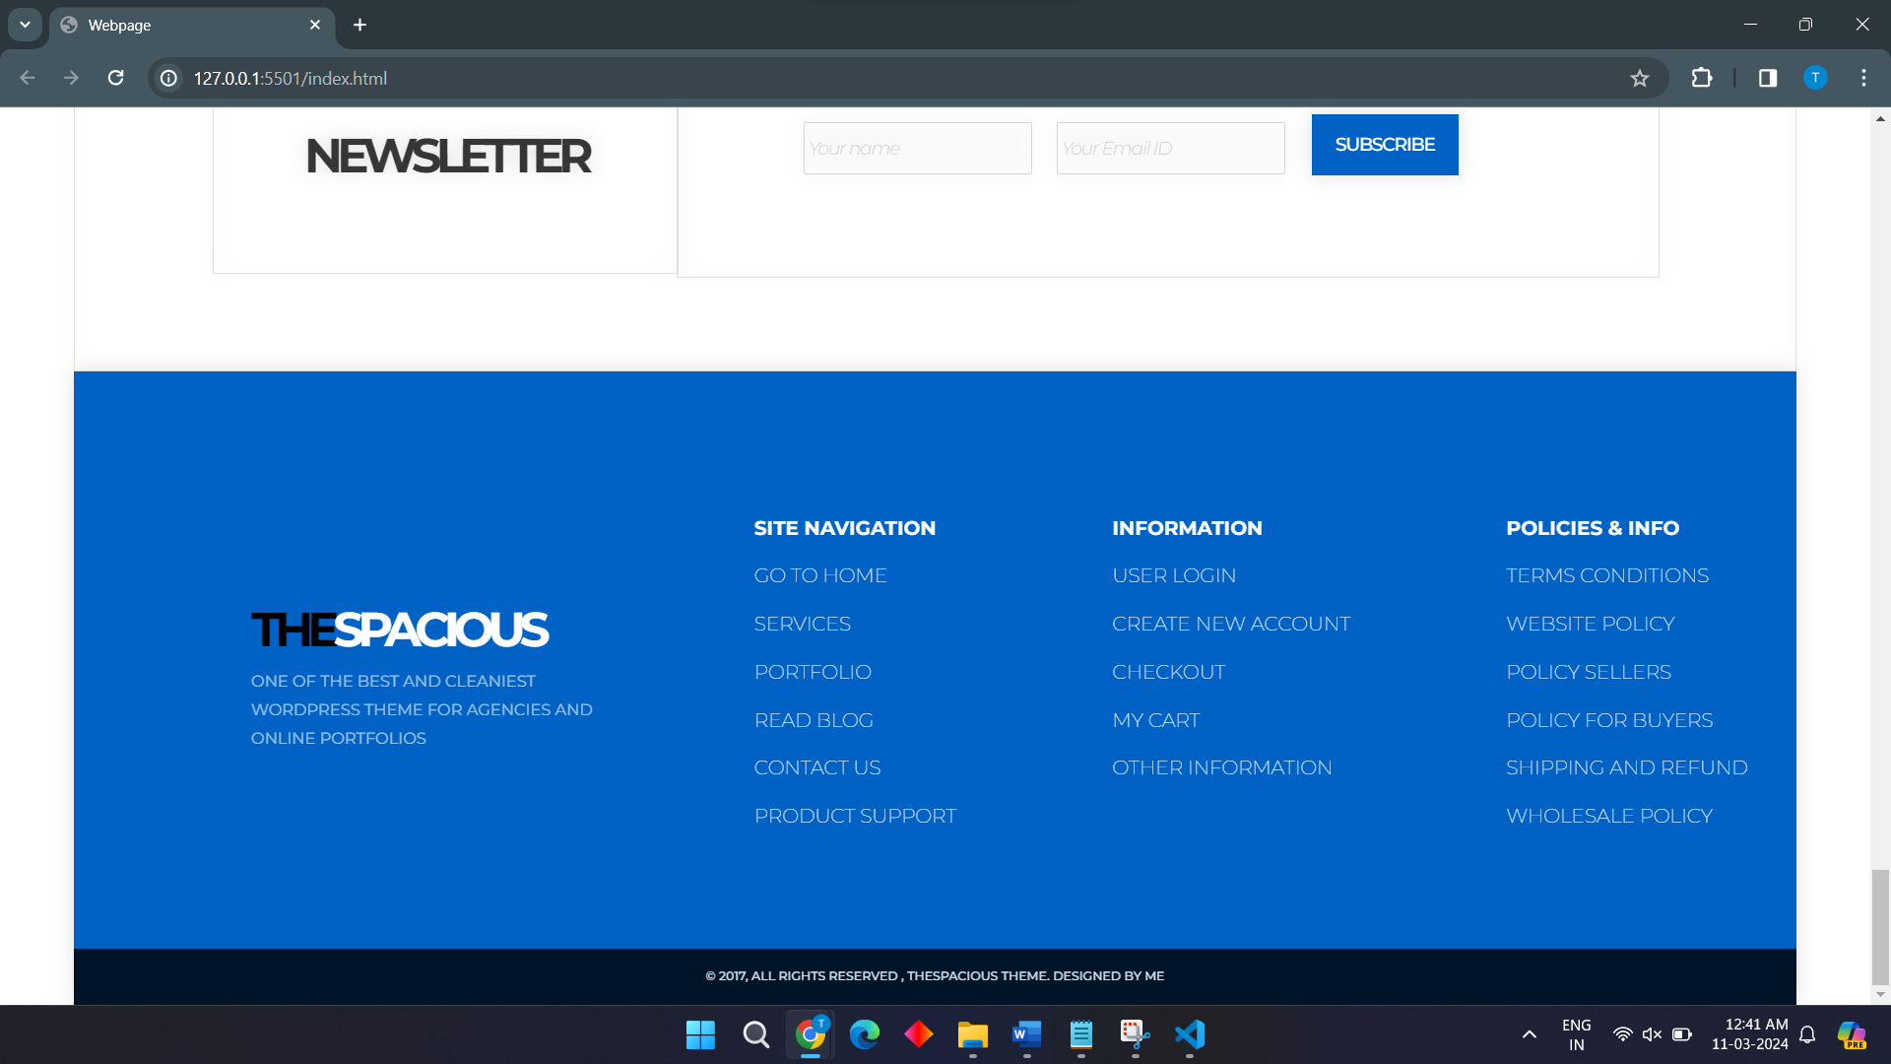

**FOR MAX WIDTH:600**

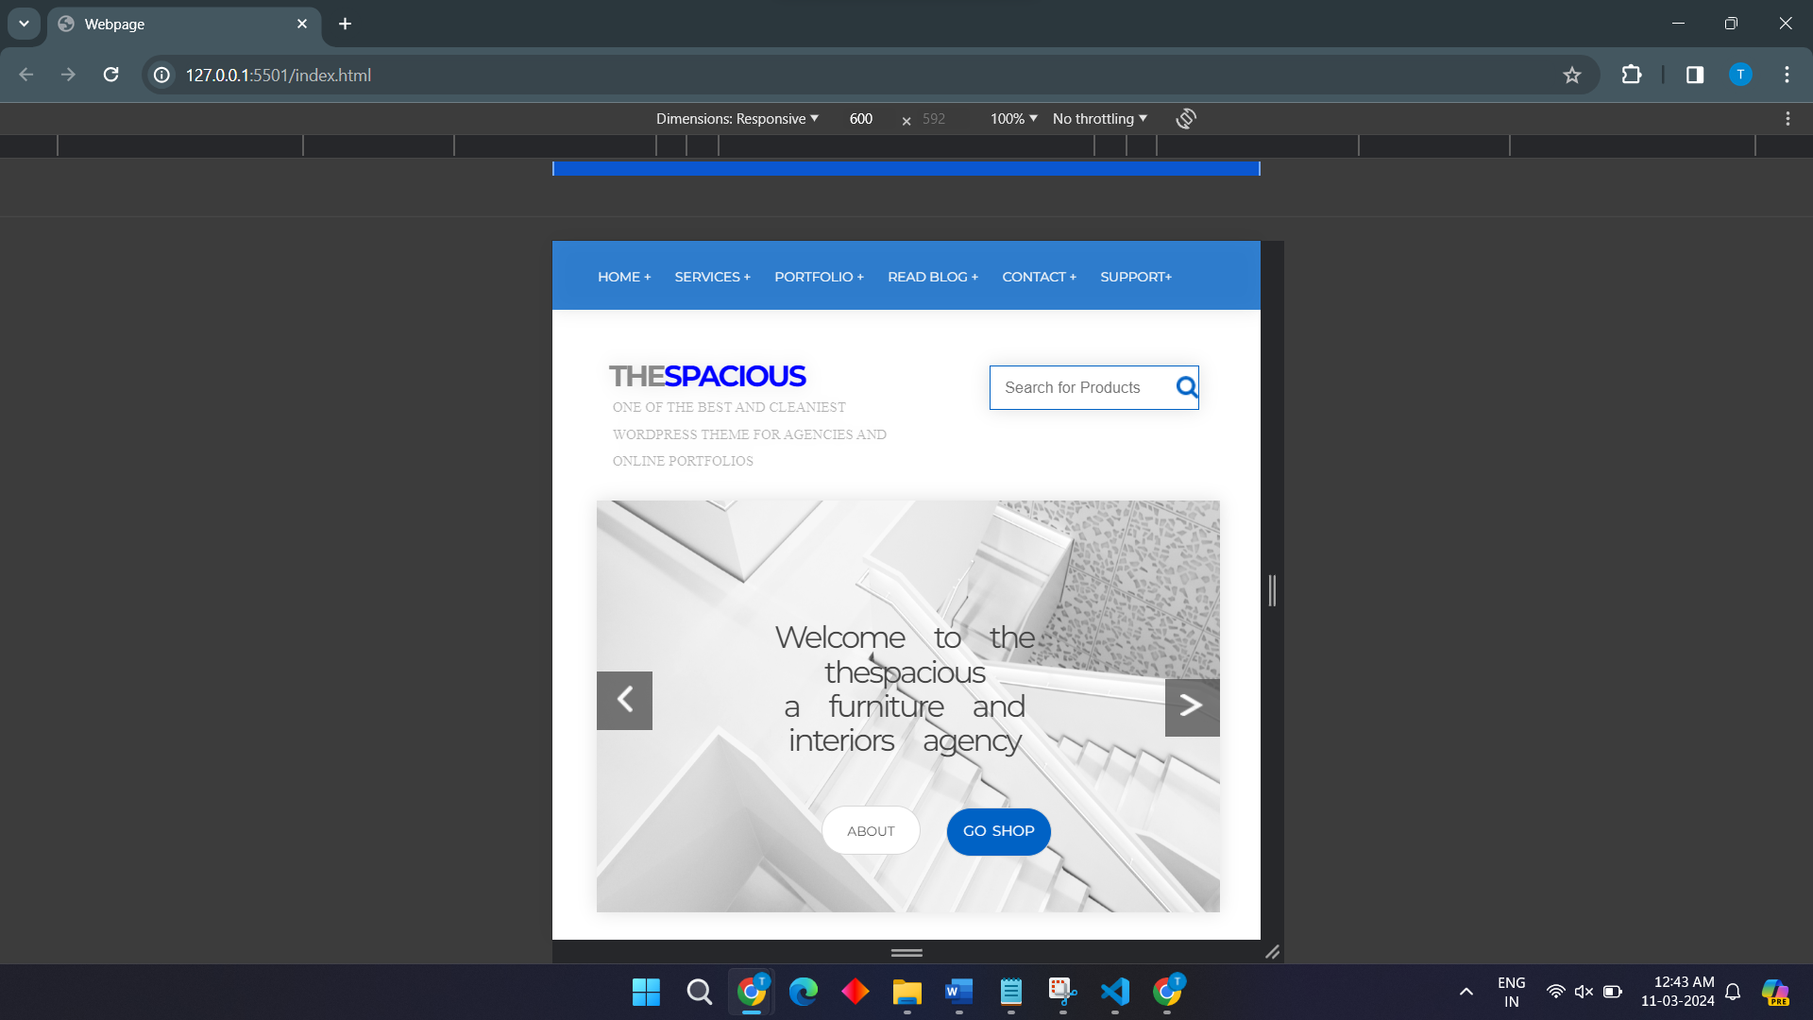

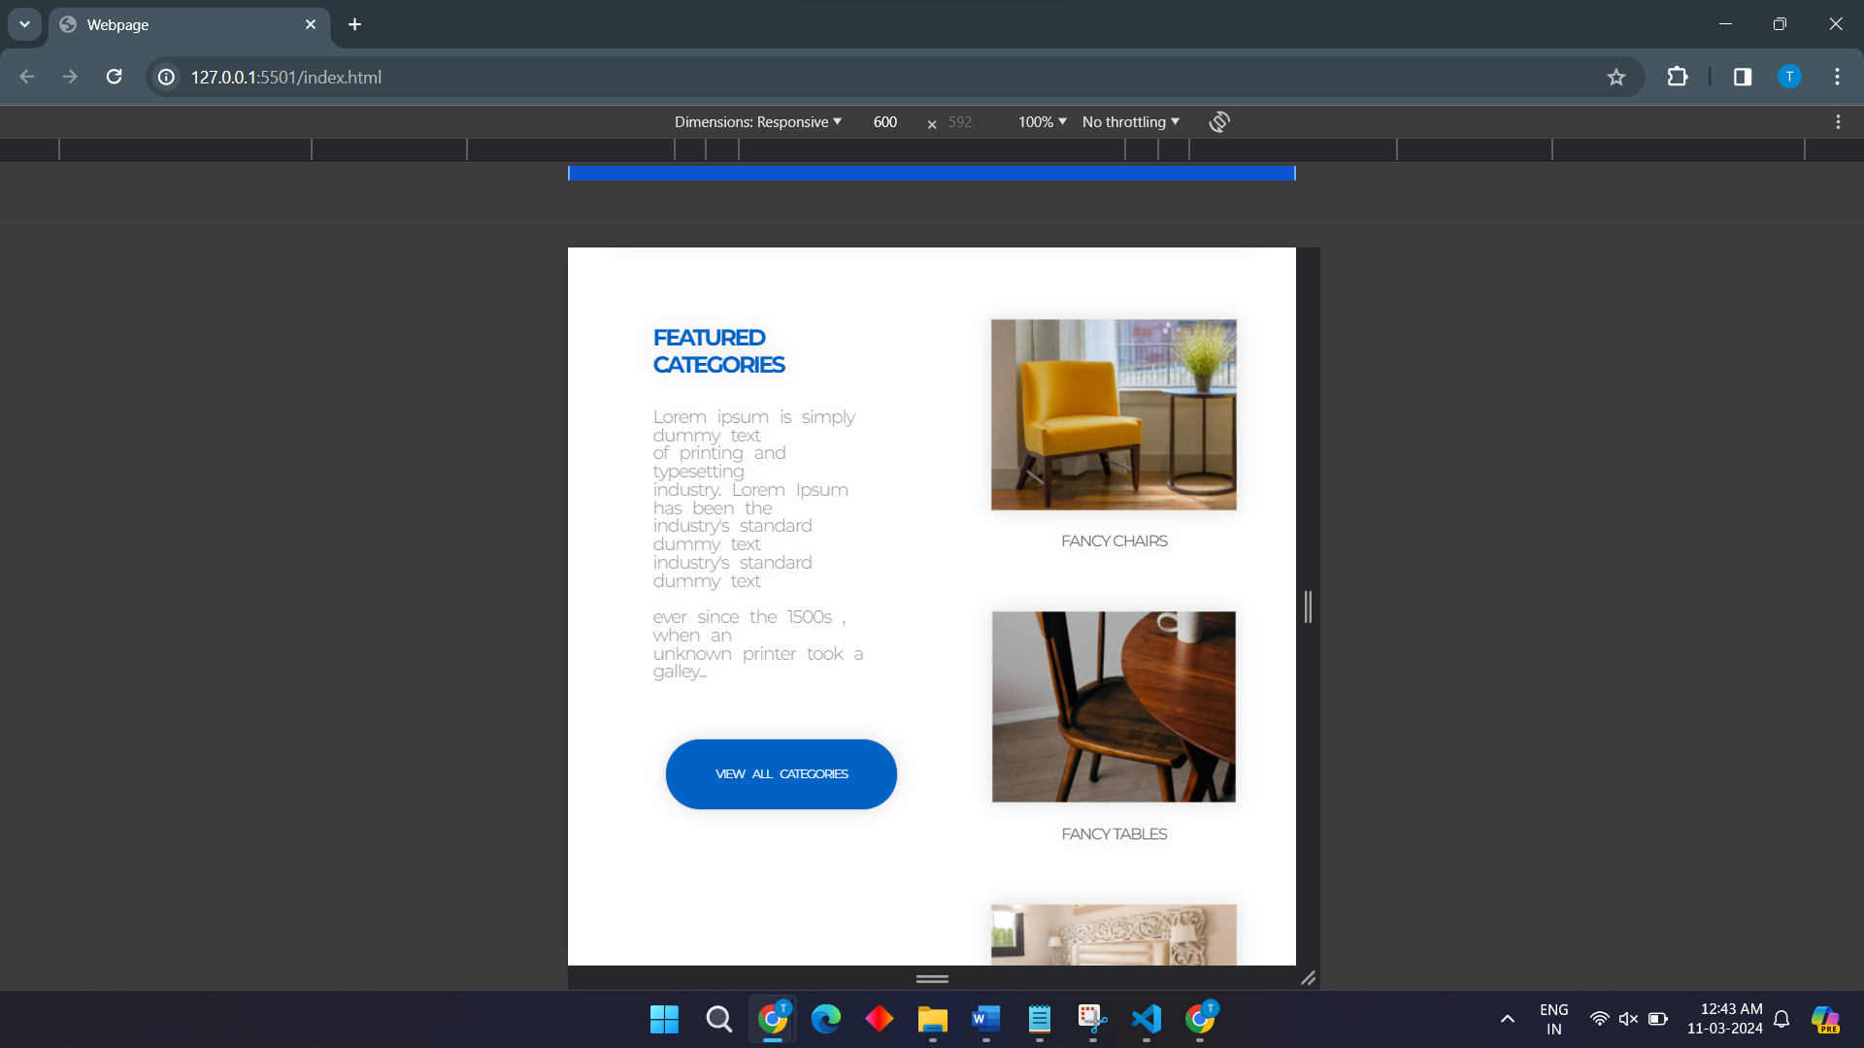

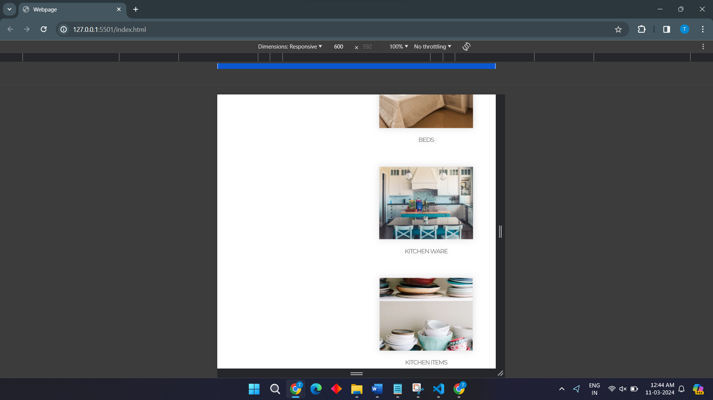

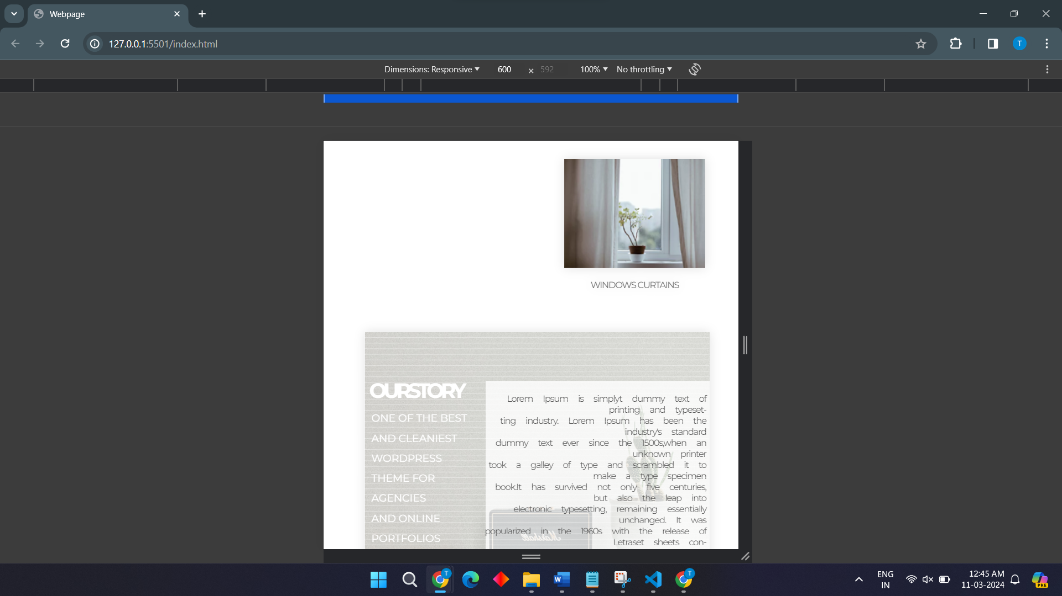

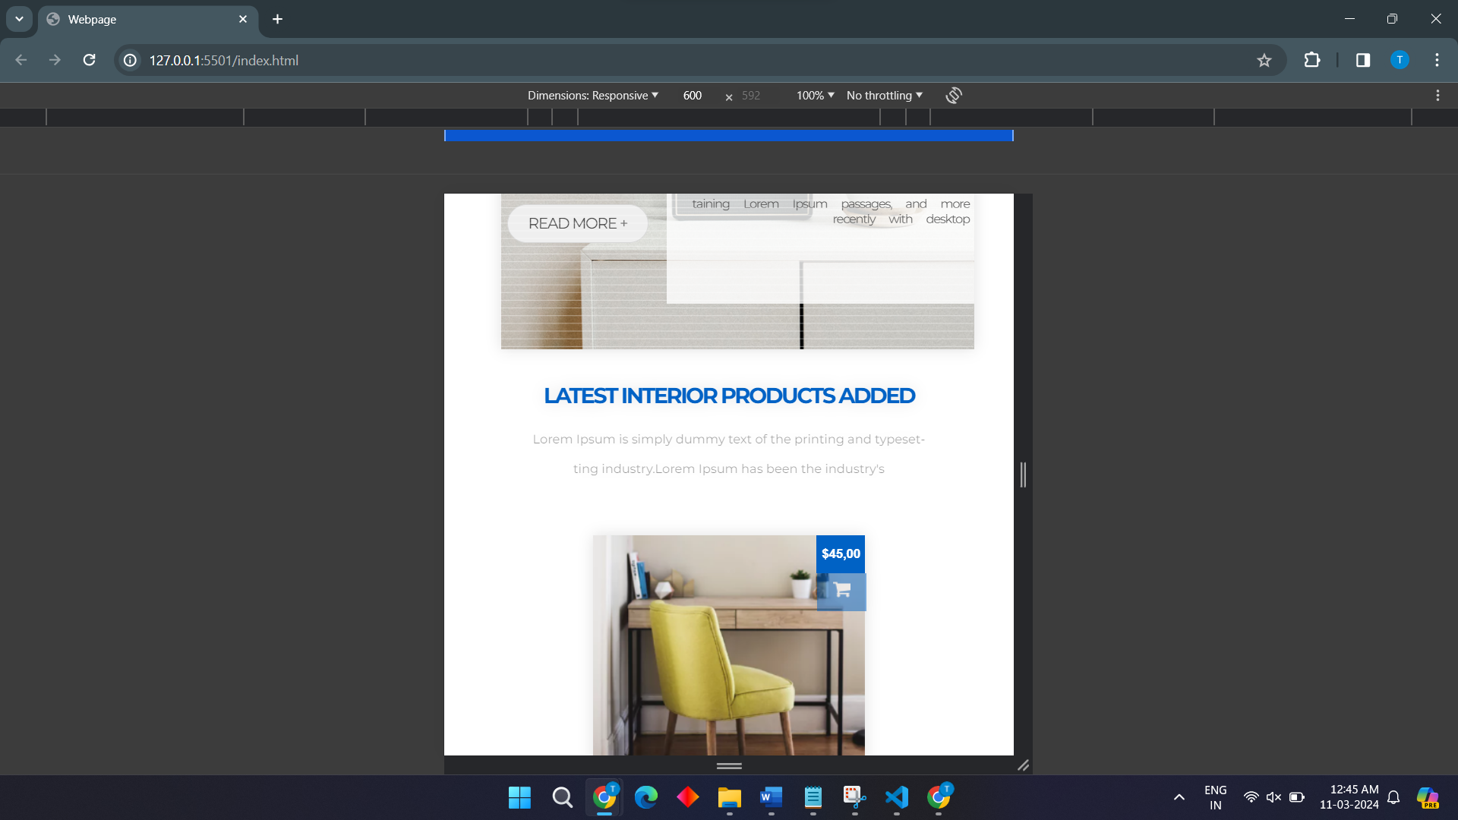

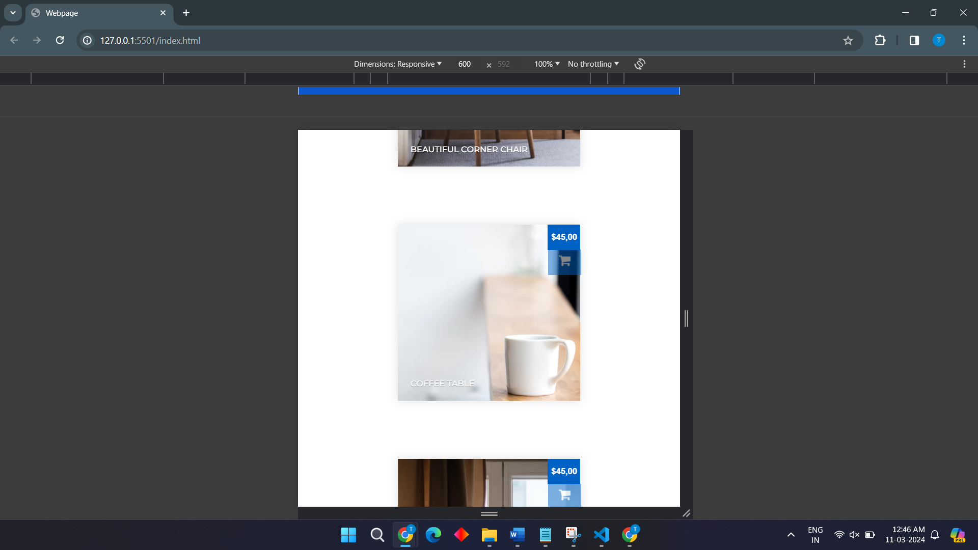

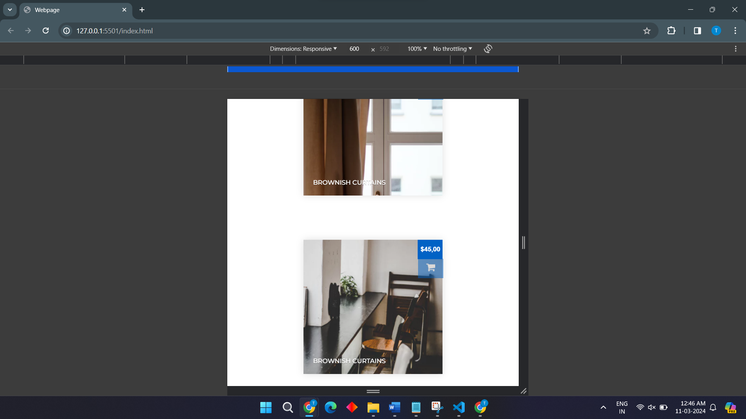

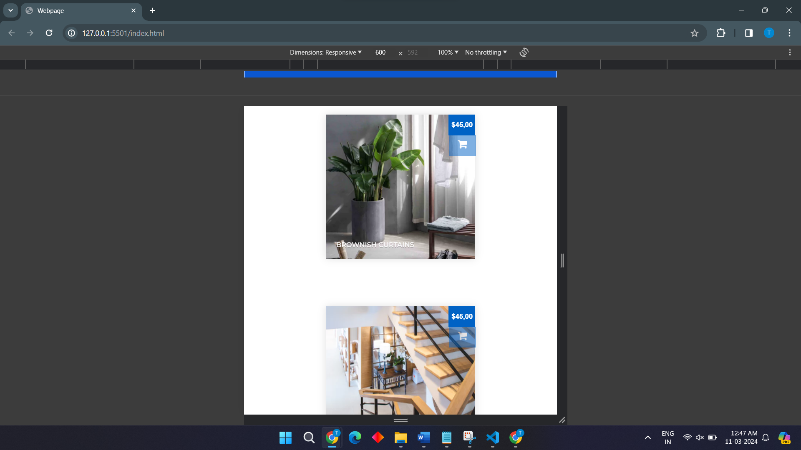

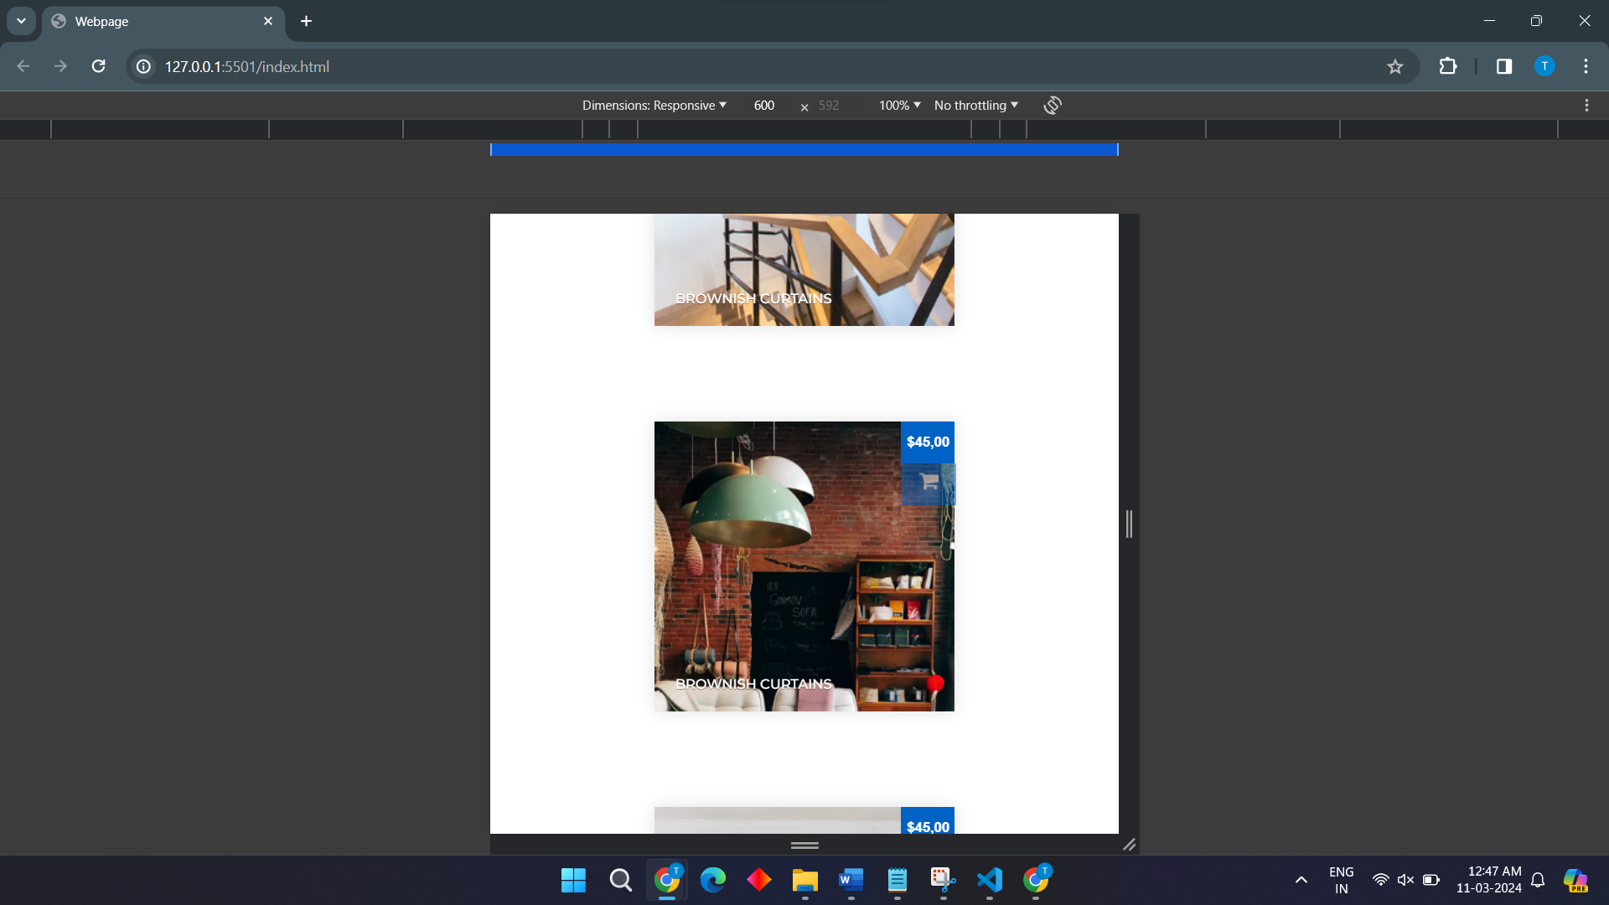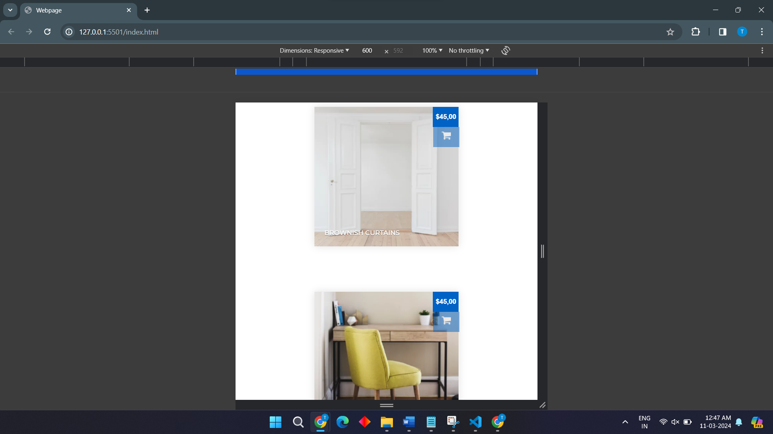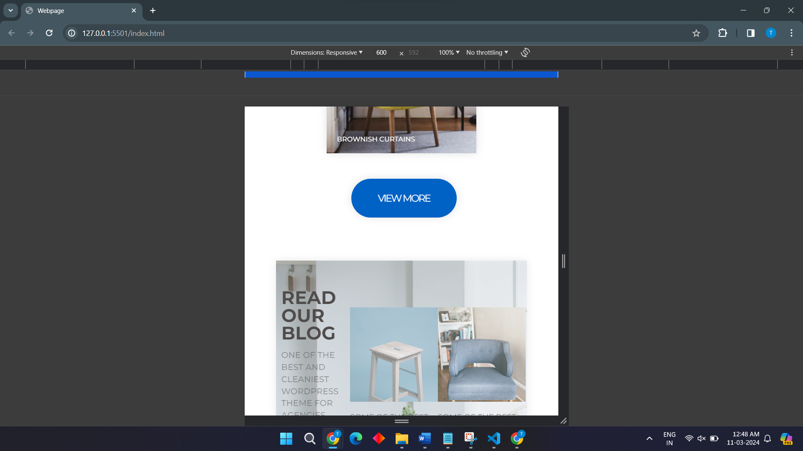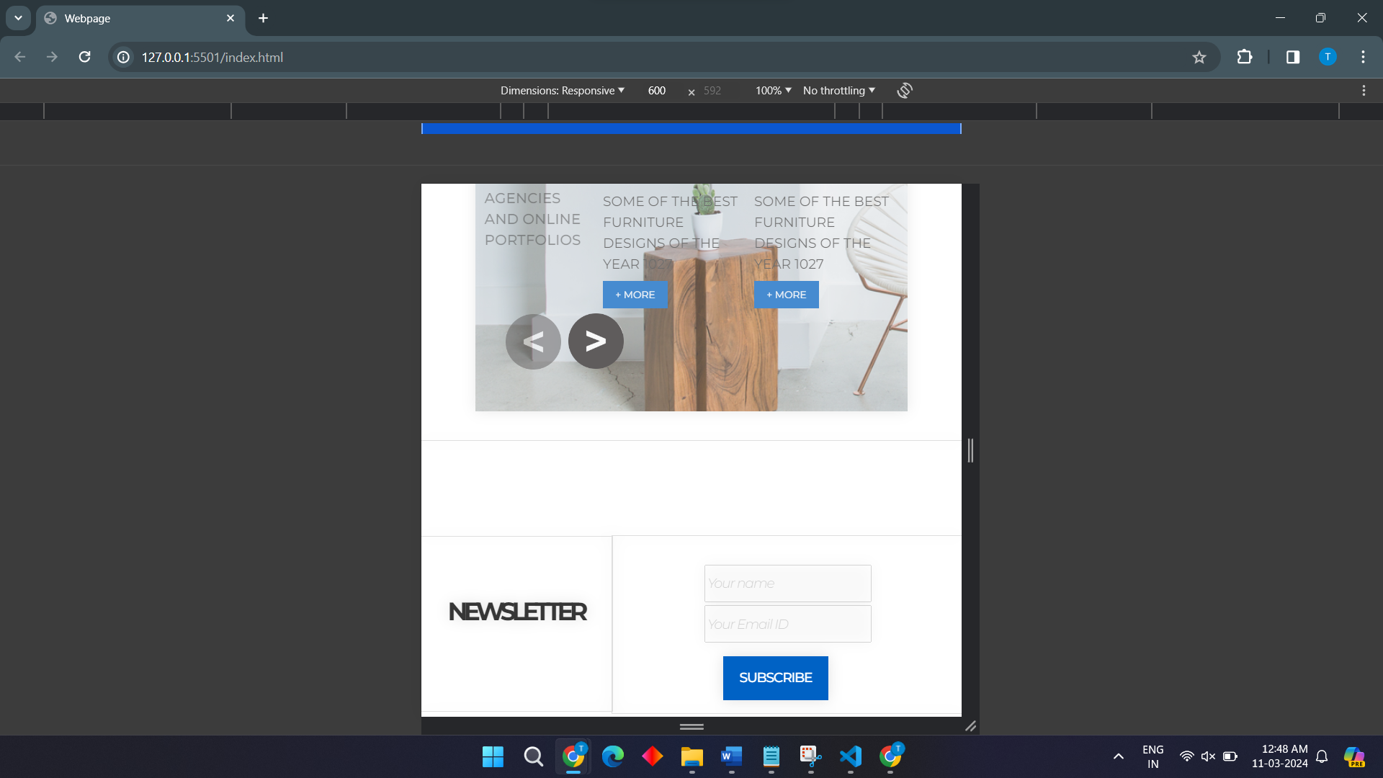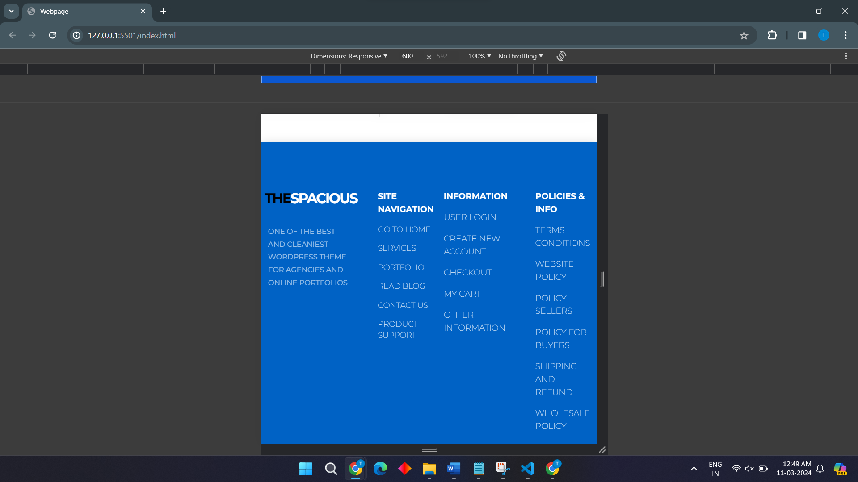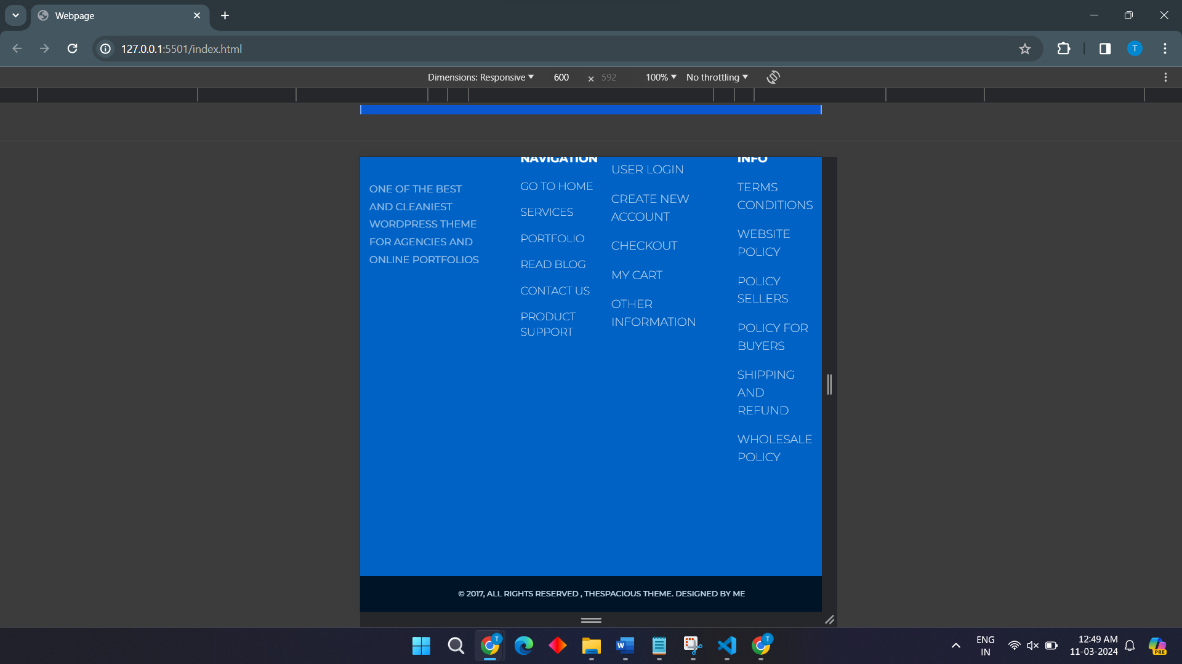

**References**

1. [**https://www.photopea.com/**](https://www.photopea.com/)
2. [**https://fonts.google.com/**](https://fonts.google.com/)
3. [**https://images.google.com/**](https://images.google.com/)